Question of the Week: Where are some of the world’s most amazing places? WB: 15.6.26
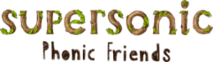  In Phonics we will be revisiting ccvcc words for example splash, splat, split as well as chunking polysyllabic words such as treetop, sandpit, picnic | In Handwriting, we will be revisiting some of the trickier letters to consolidate our learning. We will be practising the ditties and pencil strokes.  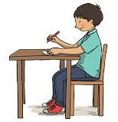 |   In Writing, we will be writing a recount of what the Gingerbread Man saw when he visited different countries.   | Maths  In maths, we will be consolidating learning on subitising, doubling, odd and even and number bonds to 10.  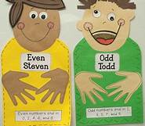
Story Time  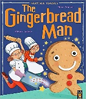  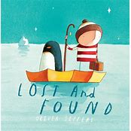 | World’s Weeks  This week each class will be learning about a different country. We will be thinking about the weather, landmarks, food, music and comparing it to England.  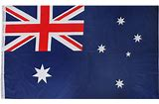  Ladybirds Caterpillars Honeybees |  |  | 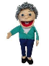  Grandma Fantastic Words:  quick fast speed rush  slow sluggish

