PE  A focus on multi skills including co-ordination, balance, agility, teamwork and safety.  Mindful minutes  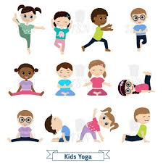 | ENGLISH  Writing dictation sentences about getting lost safety, road safety, fire safety. Instruction writing on bike safety.  HANDWRITING  Number Handwriting and words containing Curly Cal, Lens Ladder or Zig Zag Letters  PHONICS  Daily Phonics Sessions  READING  Daily Story Sessions including Helicopter Stories, Tales Toolkit Stories and Talk for Writing & Learning Poems.  Remember to bring in reading books and diaries every day. Please sign the diary when you have heard your child/ren read. | 3.11.25  This week it is…  SAFETY WEEK  We will be reading…  A range of PSHE books related to Safety including  The Pirates Next Door by Jonny Duddle   | MATHS  Number  Representing Numbers and Counting in 2s, 5s and 10s  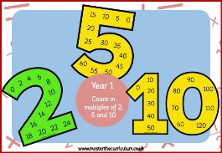 | MUSIC  Songs & rhymes  
COMPUTING

A focus and discussion regards online and e-safety.



SAFETY WEEK ACTIVITIES AT SCHOOL  Bike safety  Personal Safety / NSPCC / Childline  Anti-Bullying  Road safety – Hazard Alley  What is an emergency?  Calling 999  Fire safety  Anti-bullying  Firework / Bonfire Night  Medicine safety  Water safety  Online Safety | PSHE    Behaviour Expectations & values linked to Safety Week  With a focus on the importance of staying safe and associated vocabulary. | SAFETY WEEK ACTIVITIES AT HOME  Perhaps your child/ren could do the following at home:  - A safe house drawing  - Spot the dangers in your house poster  - Road safety scavenger hunt – take a walk and talk about the potential hazards in your neighbourhood  - Create a list of your trusted, safe adults | HOMEWORK    New homework will be issued on 6/11/25 and needs to be returned by 18/11/25.  They need to create a homework linked to Firework Safety. | FINE & GROSS MOTOR  Funky Fingers:  Cutting Skills  Crossing the mid-line  

