
Spring 1 Week 4
Question of the Week: What would you pack in your suitcase?
Activities based on the interests of the children….
This week’s NELI story is ‘Pip and Posy’, The Bedtime Frog by Axel Scheffler  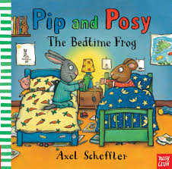  Posy forgot to take her special bedtime frog to Posy’s house. We will be talking about things that are special to us and things that make us feel happy and safe.  We will also be thinking about things we need to pack in our suitcase when we are going on holiday, thinking about differences between winter and summer clothes.  We will learn new vocabulary each day. We would love to hear if your child tells you about the new words that they have learnt. |   Our Poetry Basket Poem this week is…  Pancakes  Mix a pancake,  Stir a pancake,  Pop it in the pan,  Fry a pancake,  Toss a pancake,  Catch it if you can.  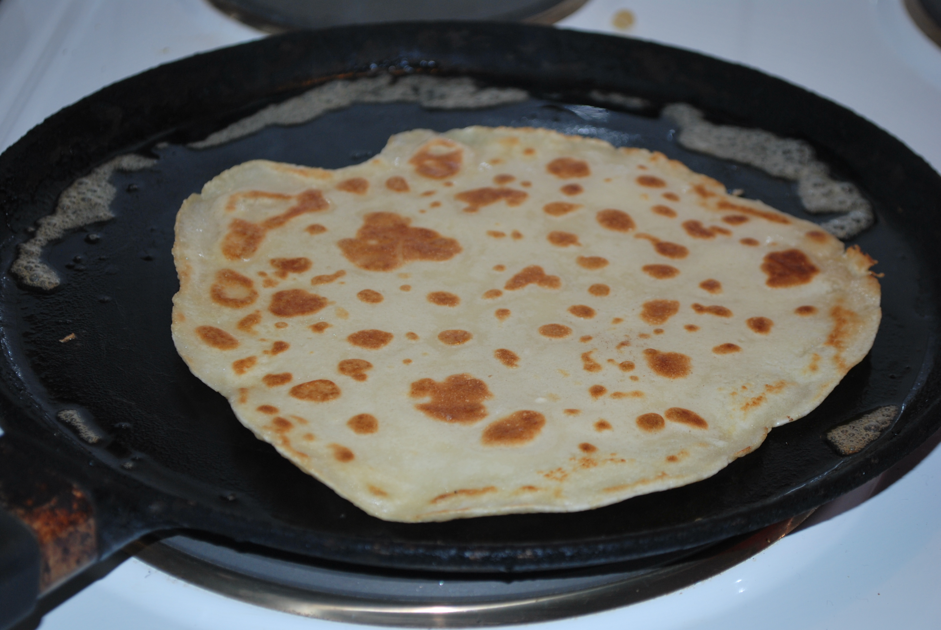 | Conversation starter: Would you rather be chased by a tickle monster or a grumpy fairy?  We will be singing the Nursery Rhyme ‘Baa Baa Black Sheep’    This week our Number Rhyme is  10 in the Bed  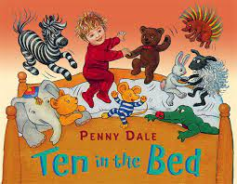
In maths we are using 5 Frames to help understand the concept of number and how much makes 5. How many more to make a finished five?    We will be separating a group of 3,4,or 5 in different ways, recognising that totals are the same. 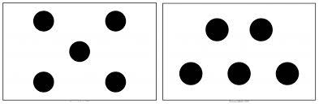 | We will be learning how to join using a split pin.  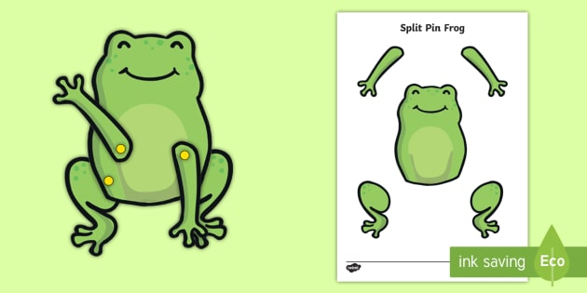 | 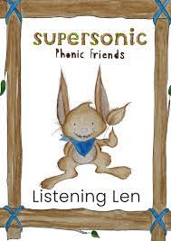  This week we will be continue to develop understanding of Alliteration. Alliteration is when several words begin with the same initial sound. For example phone, fish, flower, frog,  We are listening carefully to sounds and beginning to distinguish between the initial sounds for Alliteration and the end sounds for Rhyme.  Ideas for phonic activities at home:  Continue to play the Hide and Seek game from last week’s sheet to practise this.

