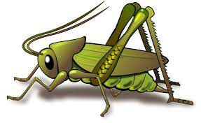
Value of the Week: Perseverance Autumn 2 Week 3
Activities based on the interests of the children….
We are continuing to embed the JHSW Values and Behaviour Expectations. This week we will be thinking more about Perseverance – We will be learning what it means to persevere so that we can keep going even when something is really tricky!    We will also be continuing to learn about how to look after our classroom and each other.  Our behaviour expectation for this week is Do work hard. | We will be listening to stories, rhymes and fairy tales.    We are starting to learn our Christmas Poems and songs ready to show you.   | This week our core text is ‘Dear Zoo’ by Rod Campbell  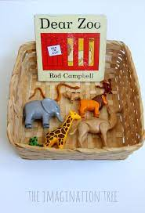  We will also continue to read familiar stories from our classroom, non fiction animal books and animal stories linked to our Core text . .
This week our Number Rhyme is ‘1,2,3,4,5 Once I caught a fish alive’  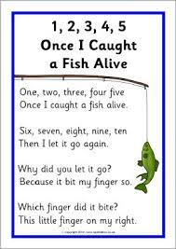  We will continue to subitise groups of objects (0-3). We will practice trying to say how many things we can see without counting. | The Nursery Rhyme of the week is ‘Jack and Jill’  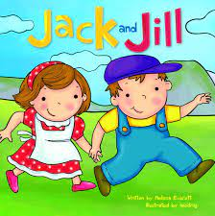  Our Creative focus this week is making small books learning how to use a stapler safely.   | Listening Len is our supersonic phonic friend. With his help we are learning to be good listeners. In the classroom we have a puppet and we have learnt some new games which your children may tell you about.  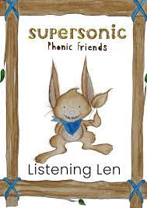  This week we be exploring Instrumental sounds. We will be identifying instruments and distinguishing between sounds and recognise and respond to sounds they hear.  Ideas for phonic activities at home:  Take a familiar song and make up a new version with new words. (ie (Name) had a road… and on that road he had a …..with a brmmm …) If you have any instruments at home use those for the sounds. Talk about the sounds they make .

