WB: 9.2.26 | Value: Good Manners | Behaviour Expectation: Do look after property
Questions of the Week: What would it be like to live on a different planet? What do aliens look like?

We will be reading the story:  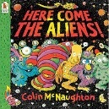  and then designing and making our own Aliens. | Grandma’s Fantastic    beat conquer defeat | Poetry Basket Poem  Climb Aboard the Spaceship!  Climb aboard the spaceship,  We're going to the moon.  Hurry and get ready,  We're going to blast off soon.  Put on your helmet,  And buckle up real tight.  Here comes the countdown,  Let's count with all our might.  10-9-8-7-6-5-4-3-2-1 Blast-off! | Tales Toolkit  We will be continuing to create class Tales Toolkit using symbols. We will be substituting But for Unfortunately and So for Fortunately Can you make up a story at home? Remember to use the sentence starters
   | One upon a time/ A long time ago there was a ……. who lived in …………  One day……  Unfortunately …..  Fortunately …..  Snip snap snover, the story is over. Snip snap snout the story is out/ Tap the nail the nail bends, this is how the story ends.
  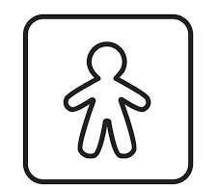
  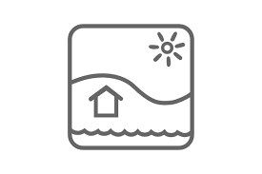
  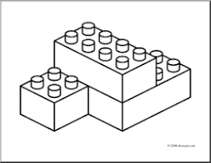
  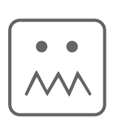
  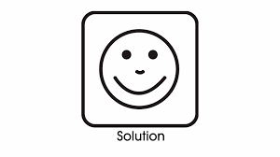
Curious Conversations:

Would it be a good thing or a bad thing if aliens lived in Earth?

Phonics  We will be learning to write the spellings for the sounds:  ur ow oi er  We will be learning to write the tricky words so, do. High Frequency Words: now, down. Please see Home Learning for further details. | 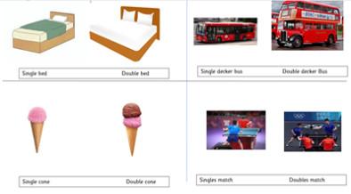  In Maths we will continue exploring Solid shapes and start to look at doubles. We will think about what double means and it’s relation to half.

