PE  Multi-Skills    Playground Equipment Games  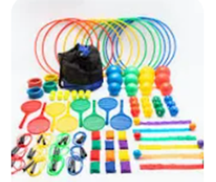  Focus: Idependent play | ENGLISH  Luna Loves to Dance  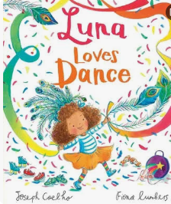  This week we will begin to write our own innovation of Luna Loves to Dance.  HANDWRITING  Practising the letter formation families and 15 fifteen.  PHONICS  Daily Choose to Use Phonics Sessions  READING  Daily Story Sessions & Learn a Poem.  Remember to bring in reading books and diaries every day. Please sign the diary when you have heard your child/ren read. | 12.10.26  Our question of the week is:  How does thinking about my day help me to be the best that I will be?  Our value this week is:  Reflection  Our Behaviour Focus this week is:  ‘All our behaviour expectations’  Poem we are Learning:  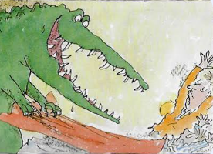  The Crocodile Roald Dahl | MATHS  Number  We will be evaluating our understanding and application of place value.  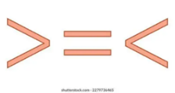  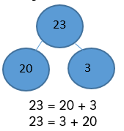  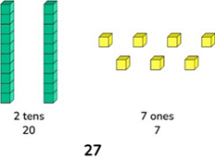 | MUSIC    To recognize repeated rhythmic patterns.  To compose and perform a simple rhythmic ostinato.
COMPUTING
To understand that algorithms follow a precise sequence.

To design an algorithm that follows a timed sequence.

ART  Sketching and Mark Making  We will be exploring different effects using new mark making techniques.  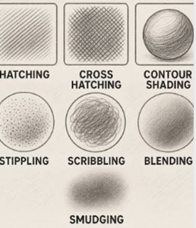 | PSHE  What does it mean to reflect?  Do show all our school Values  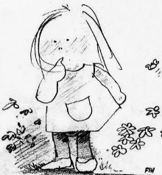    I wonder Poem | Science  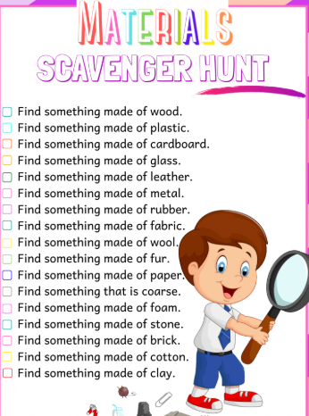  This week we will be talking about the properties of different materials and going on a material hunt. |   Reflection    Can your children complete a ‘Reflection’ challenge and as a family, talk about this value and the importance of it. | 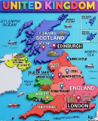    Geography  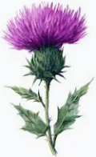  We will be learning about the four countries that make up the U.K.  This week we will be learning about Scotland including capital city, national flower, highest mountain and longest river.

