Question of the Week: What is wonderful about Wendover? WB: 12.05.26
  In Phonics we will be revising the Basic 3 and 4 spellings for the sounds, tricky words and high frequency words.  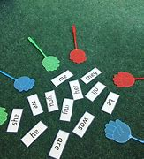 | Handwriting, We will be revising the Curly Cal letters  We will be recognising which letter family the letters come from and saying the ditties as we practise!  Our focus will be on ensuring |   In Writing, we are going to be using positional language to write directions to describe Rosie’s Walk.  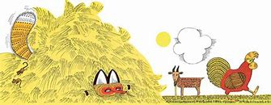 | Maths  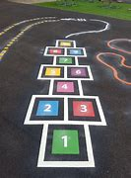  In Maths, the children will be thinking about ordinality: considering where numbers to 10 are in relation to each other. The children will think carefully about which number is more or less whilst using playing with number tracks. We will also be using positional language to describe a location and when using the obstacle course.  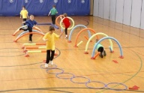
  Creepy Crawlies  Creepy crawly up my arm,  A spotty little bug.  Then it crawled up to my neck,  I gave a little shrug.  Then it climbed a little more,  And settled on my nose.  So, I gave a mighty snore,  And it scuttled to my toes. | What is wonderful about Wendover?  This week the children will be taking part in a walk around Wendover. They will be thinking about how Wendover was different in the past. For example, how the windmill would have had sails and been a working mill.  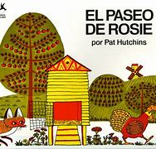  Our core text for the week will be -  We will also be reading:  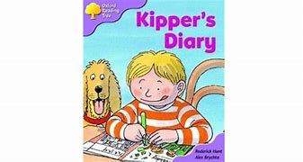  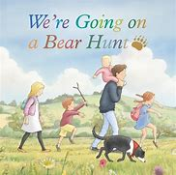  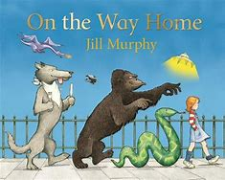 |  | Parents Hints and Tips  Wendover Walk Trip  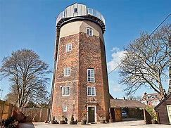  Wednesday 13th May 2026  Coats & Sunhats    Please ensure children have a waterproof coat and a sunhat everyday. Please apply sun lotion if needed - dependent on the forecast.

