English  This week we will be reading The Little Red Hen and then writing a recount. | Maths  We will be recognising the addition symbol and adding numbers together below 10. | PE  Our focus in PE in this half term will be multi-skills Please ensure your child has a full, named PE kit including joggers as we will sometimes be outside.
Music  We are learning songs and moving our body to the pulse. | Week beginning 06.10.25  Incredible Me!  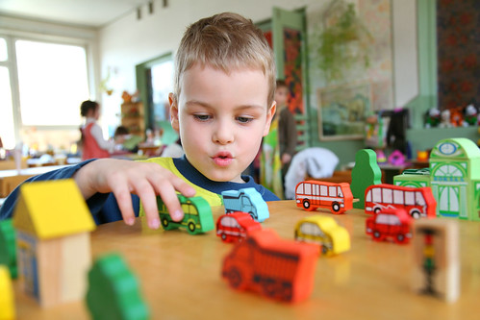 | Science  Animals and Humans  We will be observing, investigating and comparing the human body. We will be working on our questioning skills, identifying what makes a good question.
Poetry  We will be looking at classic Poems from our “Poetry Basket”.  This half term our poems are “All About Me” |  | Art  This half term we are going to be looking at sketching and mark making in Art and using H and B pencils to create different effects.
 | PSHE  This half term we are focusing on looking at our school values and what they mean. This week we are going to be looking at respect. | Geography  Next week we will be using observational skills to study the geography of our school and the grounds, including human and physical features.
Phonics
We will be recapping and reviewing Basics 4 and reading CVCC words and B4 tricky words.

