PE  A focus on Dance & Christmas Dance  Mindful minutes  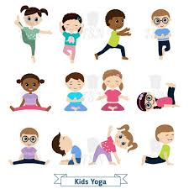 | ENGLISH  Narrative ‘The Hungry Badger’: Story innovating & writing  HANDWRITING  Number Handwriting and words containing Curly Cal, Lens Ladder or Zig Zag Letters  PHONICS  Daily Phonics Sessions  READING  Daily Story Sessions including Helicopter Stories, Tales Toolkit Stories and Talk for Writing & Learning Poems.  Remember to bring in reading books and diaries every day. Please sign the diary when you have heard your child/ren read. | 1.12.25  We will continue to focus on our school Behaviour Expectations & Values.  We will be reading:    The Hungry Badger | MATHS  Addition – Partitioning  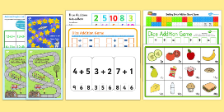  Numbots – We would like children practise their number bonds to 10 and 20 during their Home Learning. | MUSIC  Songs & rhymes  Christmas songs  
 |  |  | GEOGRAPHY  Following on from our Year Group Walk around Wendover, the children will plot Human & Physical features on a map.   | COMPUTING  Scratch Coding  
ART/CRAFT  Mark making with watercolours  Sketching  Christmas calendars  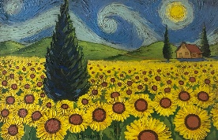 | PSHE    Behaviour Expectations & values  Growth Mindset | ACTIVITIES AT HOME  Perhaps your child/ren could do the following at home:  - Visit Roald Dahl Museum in Aylesbury or Great Missenden  - Read Roald Dahl Books  - Watch Roald Movies  - Write a Tales Toolkit story  - Use mark making and pencils / paints to complete a piece of art  - Draw a picture in the style of Quentin Blake | HOMEWORK    Homework was issued on 20/11/25 and will need to be returned on 2/12/25. This is on the weather.  New homework will be issued on 4/12/25 and needs to be returned on 16/12/25. It will on Christmas Traditions. | FINE & GROSS MOTOR  Funky Fingers:  Cutting Skills  Crossing the mid-line  
HISTORY
Roald Dahl.
Focus on a significant local person, facts and chronological order
