Autumn 1 Week 8
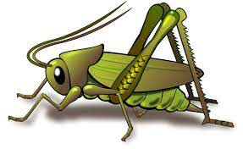
Growth Mindset
Activities based on the interests of the children….
Our story  This week our core text is ‘Beautiful Oops!’  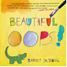  This story supports our learning based on growth mindset. We will be thinking about what we can and can’t do and thinking about how we will keep trying and having a go anyway.  We will be reflecting on all of our behaviour expectations this week: do look after property, do work hard, to be kind and helpful, do be polite and do listen.  We will also continue to read familiar stories from our classroom. | Poetry basket  We will be listening to stories, rhymes and fairy tales.  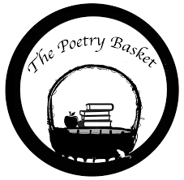  This week we will be revisiting and reciting the three poems learn this half term. They are called Chop Chop, Wise Old Owl and Falling Apples.  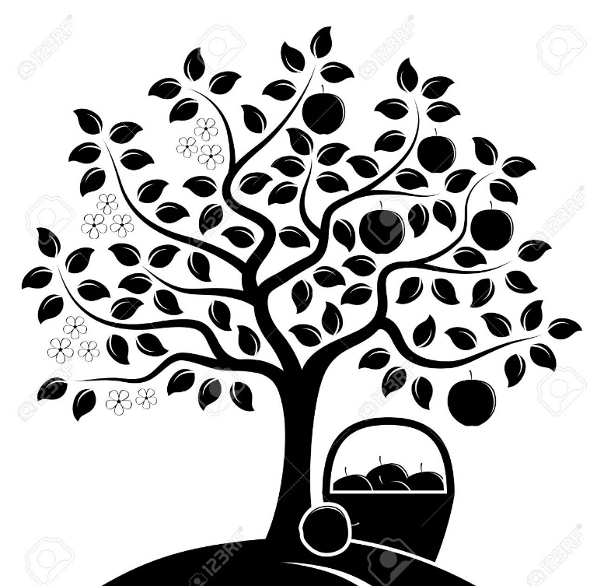    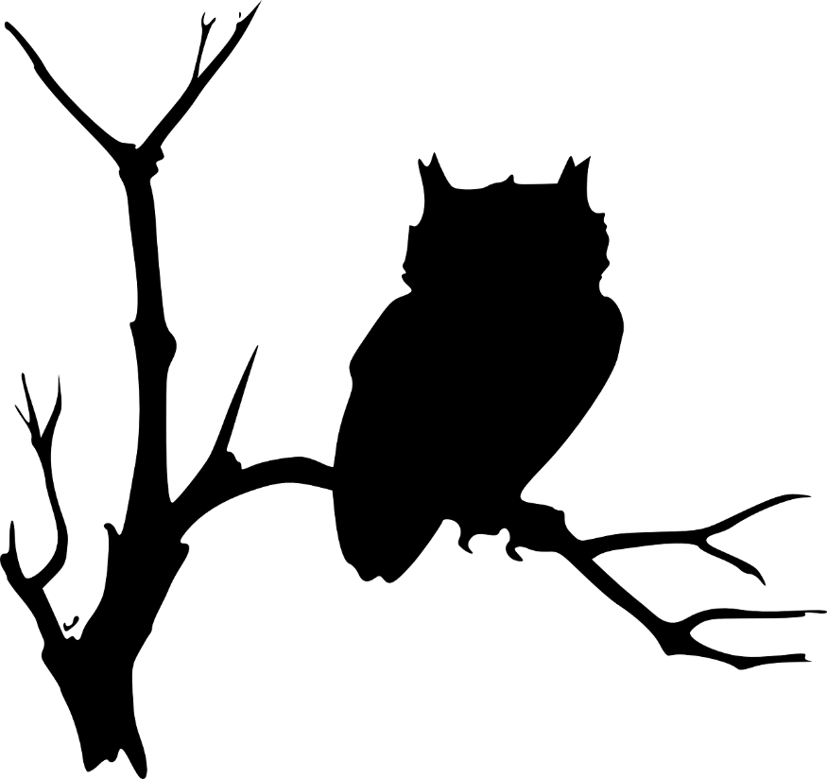  Crickets are doing so well learning these poems.  Ask your child to recite one and show you the actions. | Phonics  We will be continuing to use our listening ears by playing lots of games. This week we will be using our bodies to make and hear sounds.  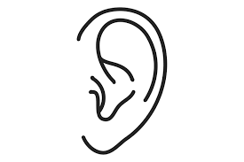
Maths  This week our Number Rhyme is ‘5 Green Bottles’    We will continue to subitise groups of objects (0-3). We will practice trying to say how many things we can see without counting.  “What do you see? How do you see it?” We will be encouraging the children to represent their Maths by mark making. |   Expressive arts and design  We will be looking at different sized pumpkins and doing observational drawings of them. Later on in the week we will be opening them up to see what is inside and use our fine motor skills to scrape out what is inside.  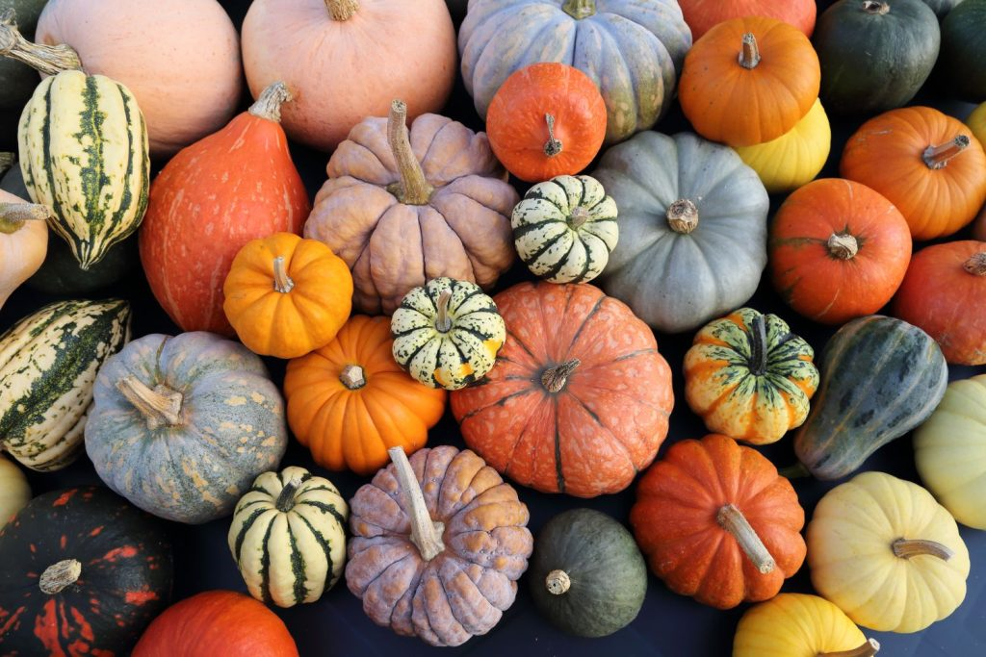 | Mark making  We are continuing to develop our gross motor skills with our ‘Squiggle while you Wiggle’ dance. We will be practising our mark making whilst we play. We will be practising the below patterns.  | ------ S O  We will also be continuing to make different marks outside using large up/down and across movements whilst using the water brushes, chalks, sand, and in the air with noodles and scarves.

