THE JOHN HAMPDEN SCHOOL WENDOVER – SCHOOL UNIFORM ORDER FORM

CHILD’S NAME …………………………………………………………………………………….

Item |  |  | Price | Quantity | Size | Colour  (Please state which colour you would like) | Total cost
Grey Trousers (age 3/4) Phasing Out |  | 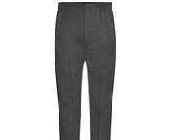 | £4.00
Pleated Skirt Navy (age 3/4,) – limited stock only 5 left |  | 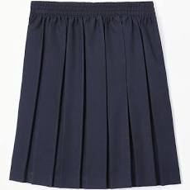 | £5.50
Fleece (age 3/4,5/6, 7/8 with logo) |  | 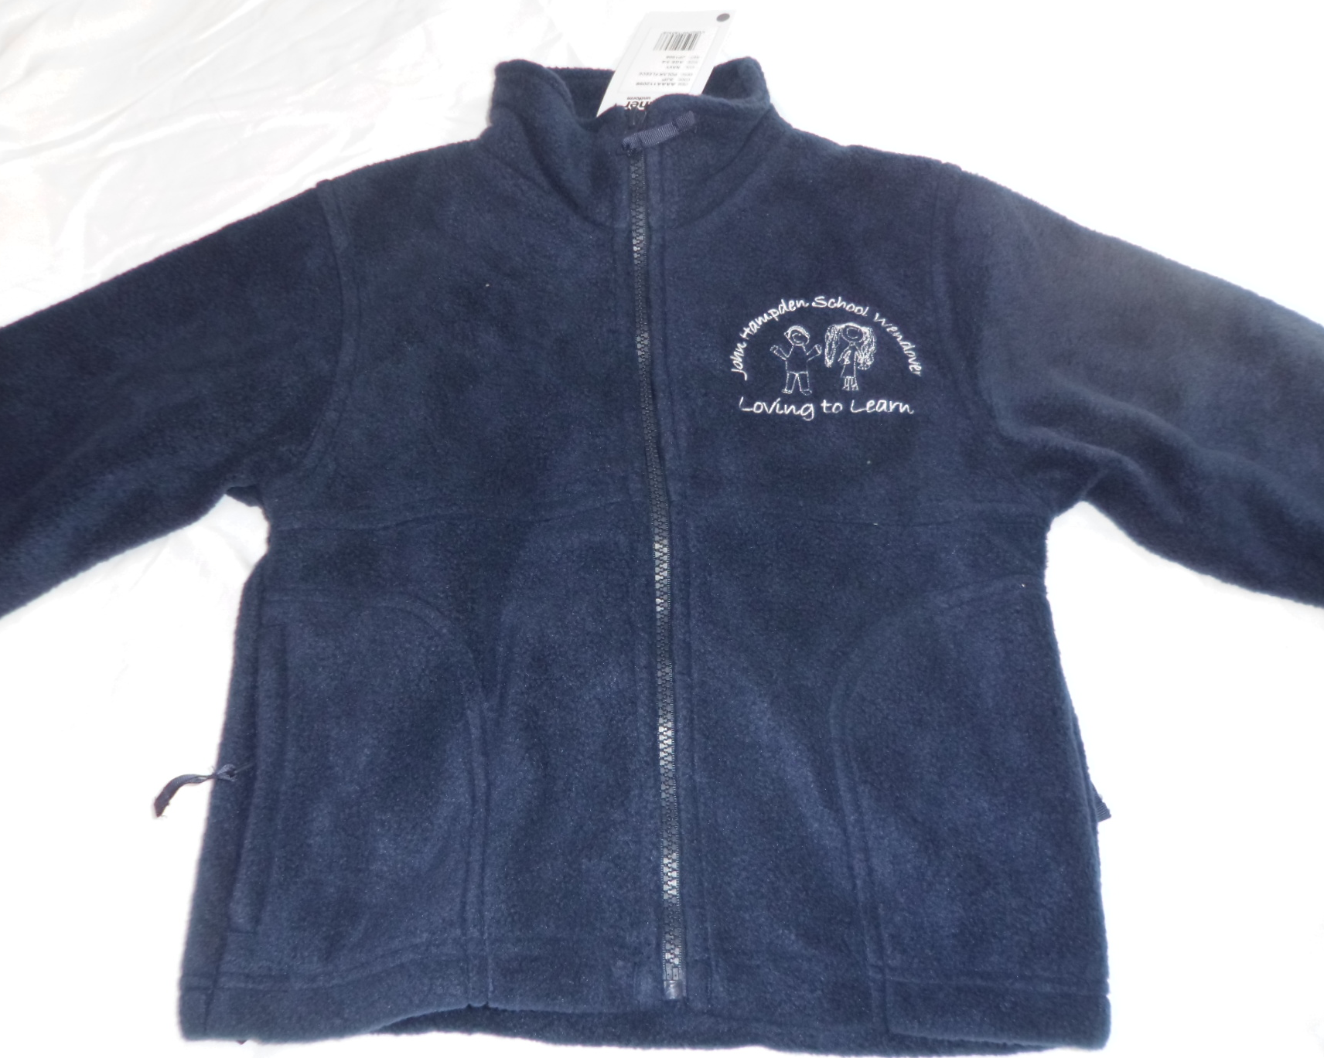 | £15.00
Navy Sweatshirt with logo (24”, 26”, 28”, 30”, 32”) |  | 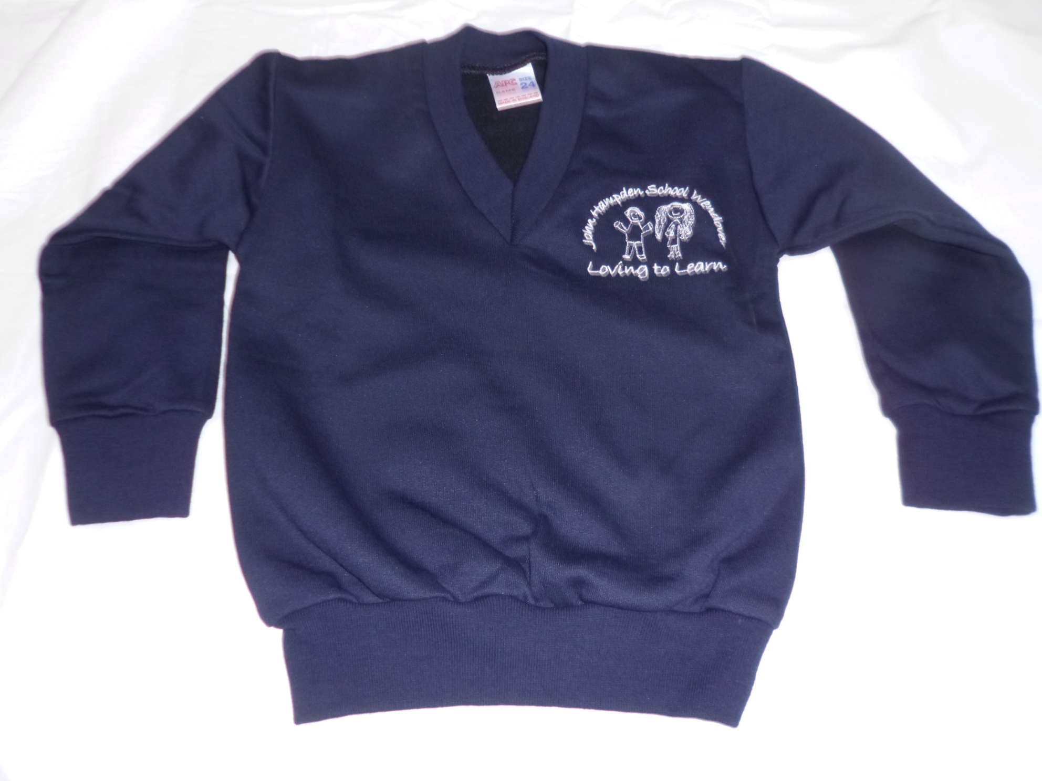 | £11.50
Navy Sweatshirt Cardigan with logo (24”, 26”, 28”, 30”) |  | 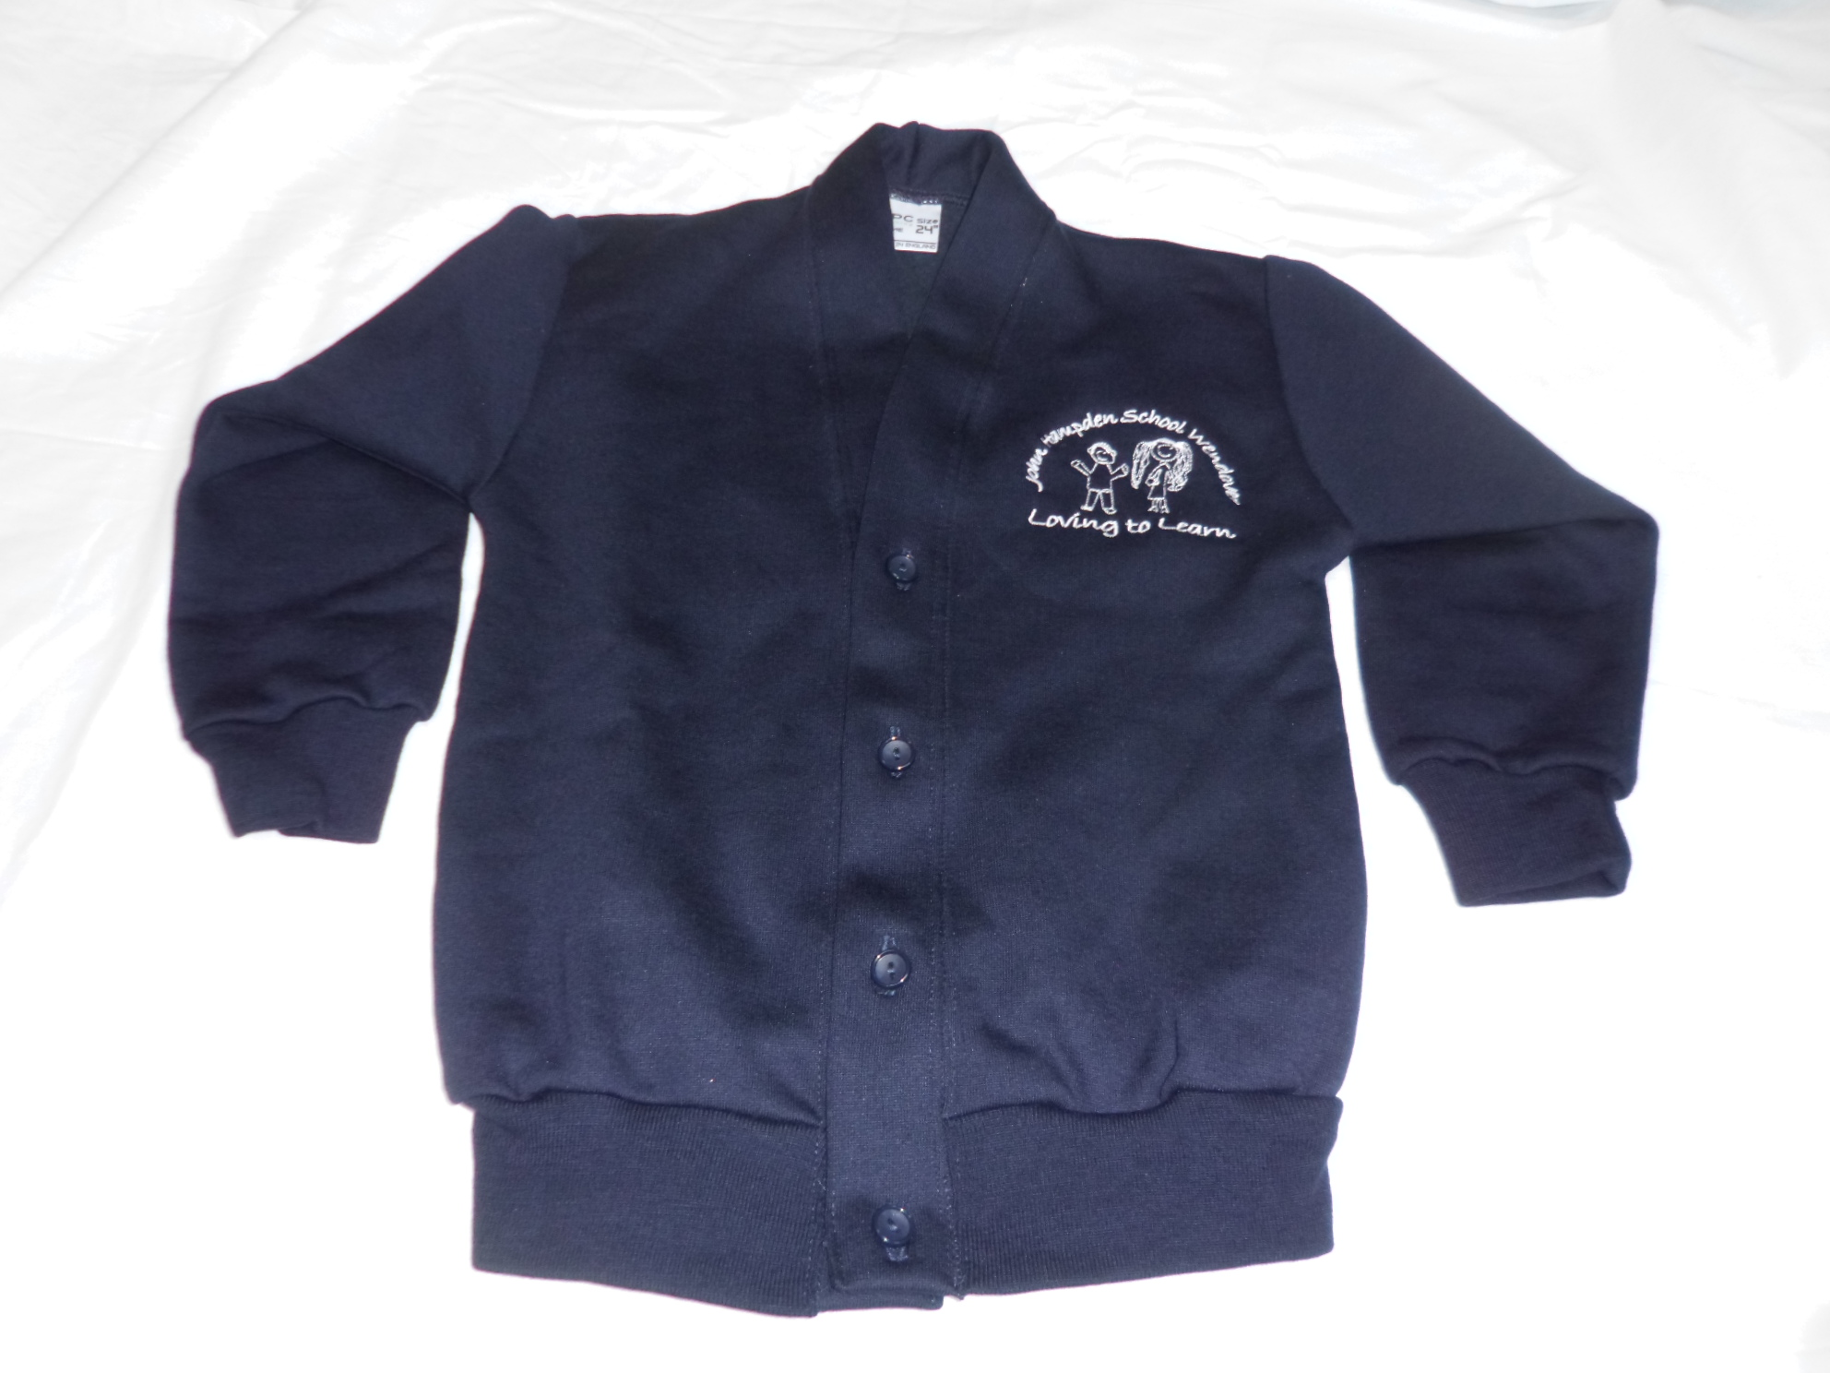 | £11.50
White polo shirt with logo (age 3/4, 5/6, 7/8) |  | 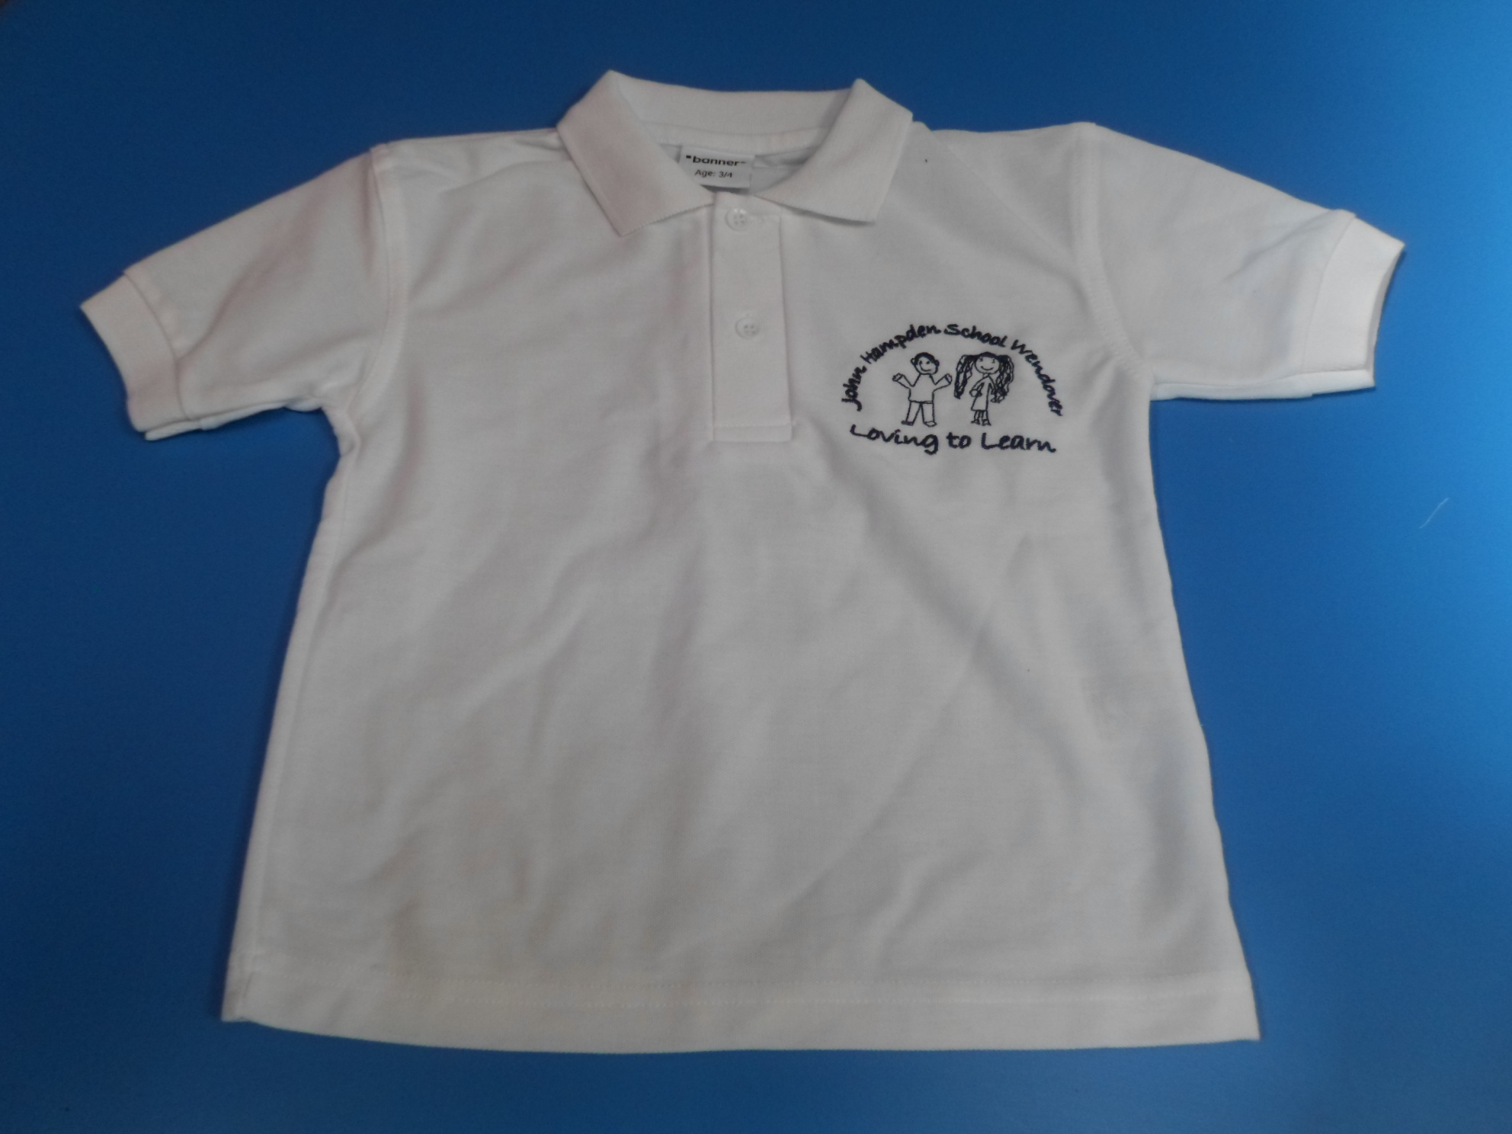 | £10.00
White PE t-shirt with logo (age 3/4, 5/6, 7/8) |  | 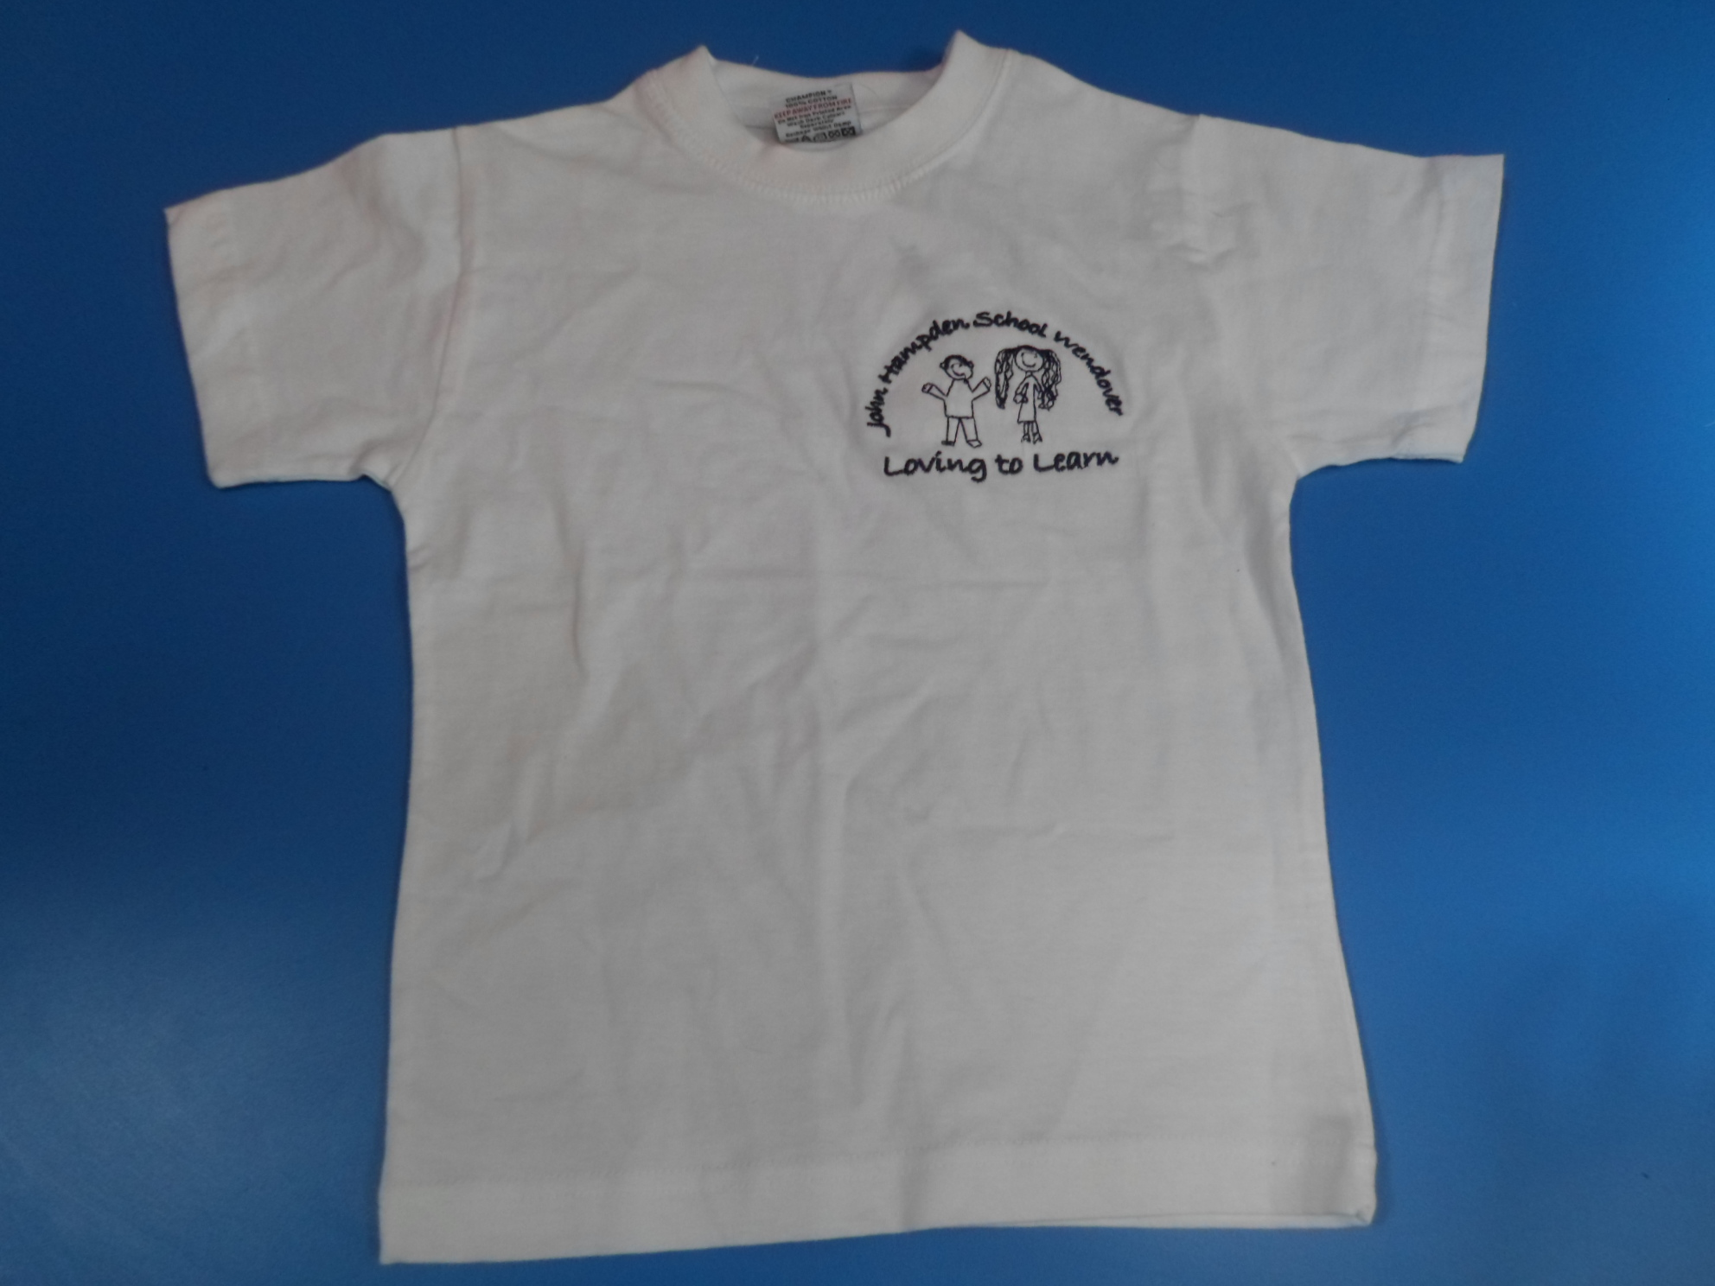 | £7.00
Navy PE shorts (22, 24”, 26”, 28”) |  | 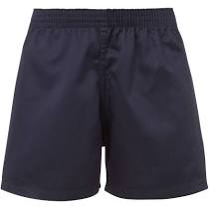 | £6.00
PE bag (black, red, pink, purple, royal blue, navy, emerald green, bottle green, yellow)  PLEASE STATE COLOUR |  | 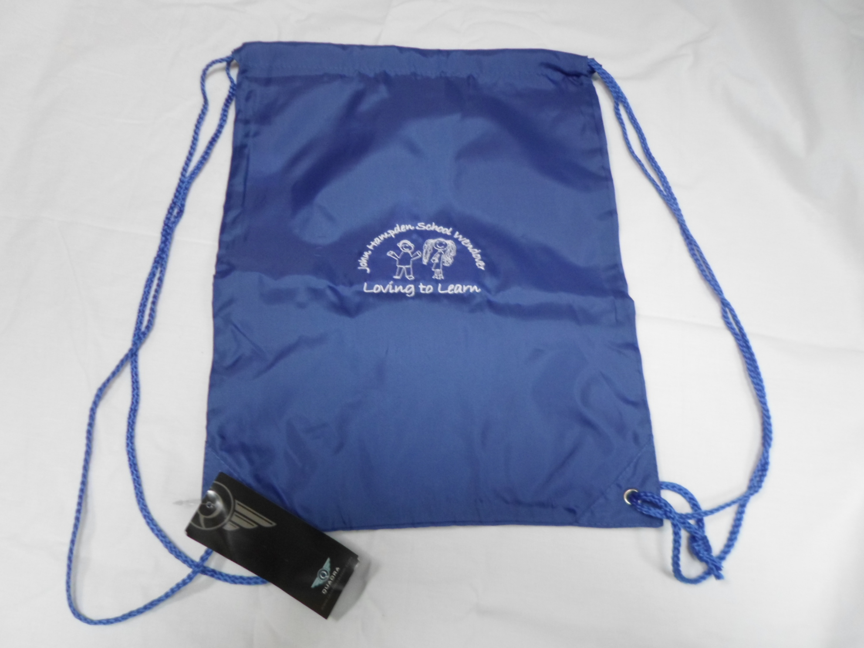 | £4.50
Waterproof reading folder/book carrier with logo (purple, navy, black, red, emerald green, royal blue, bottle green, jade, yellow)  PLEASE STATE COLOUR |  | 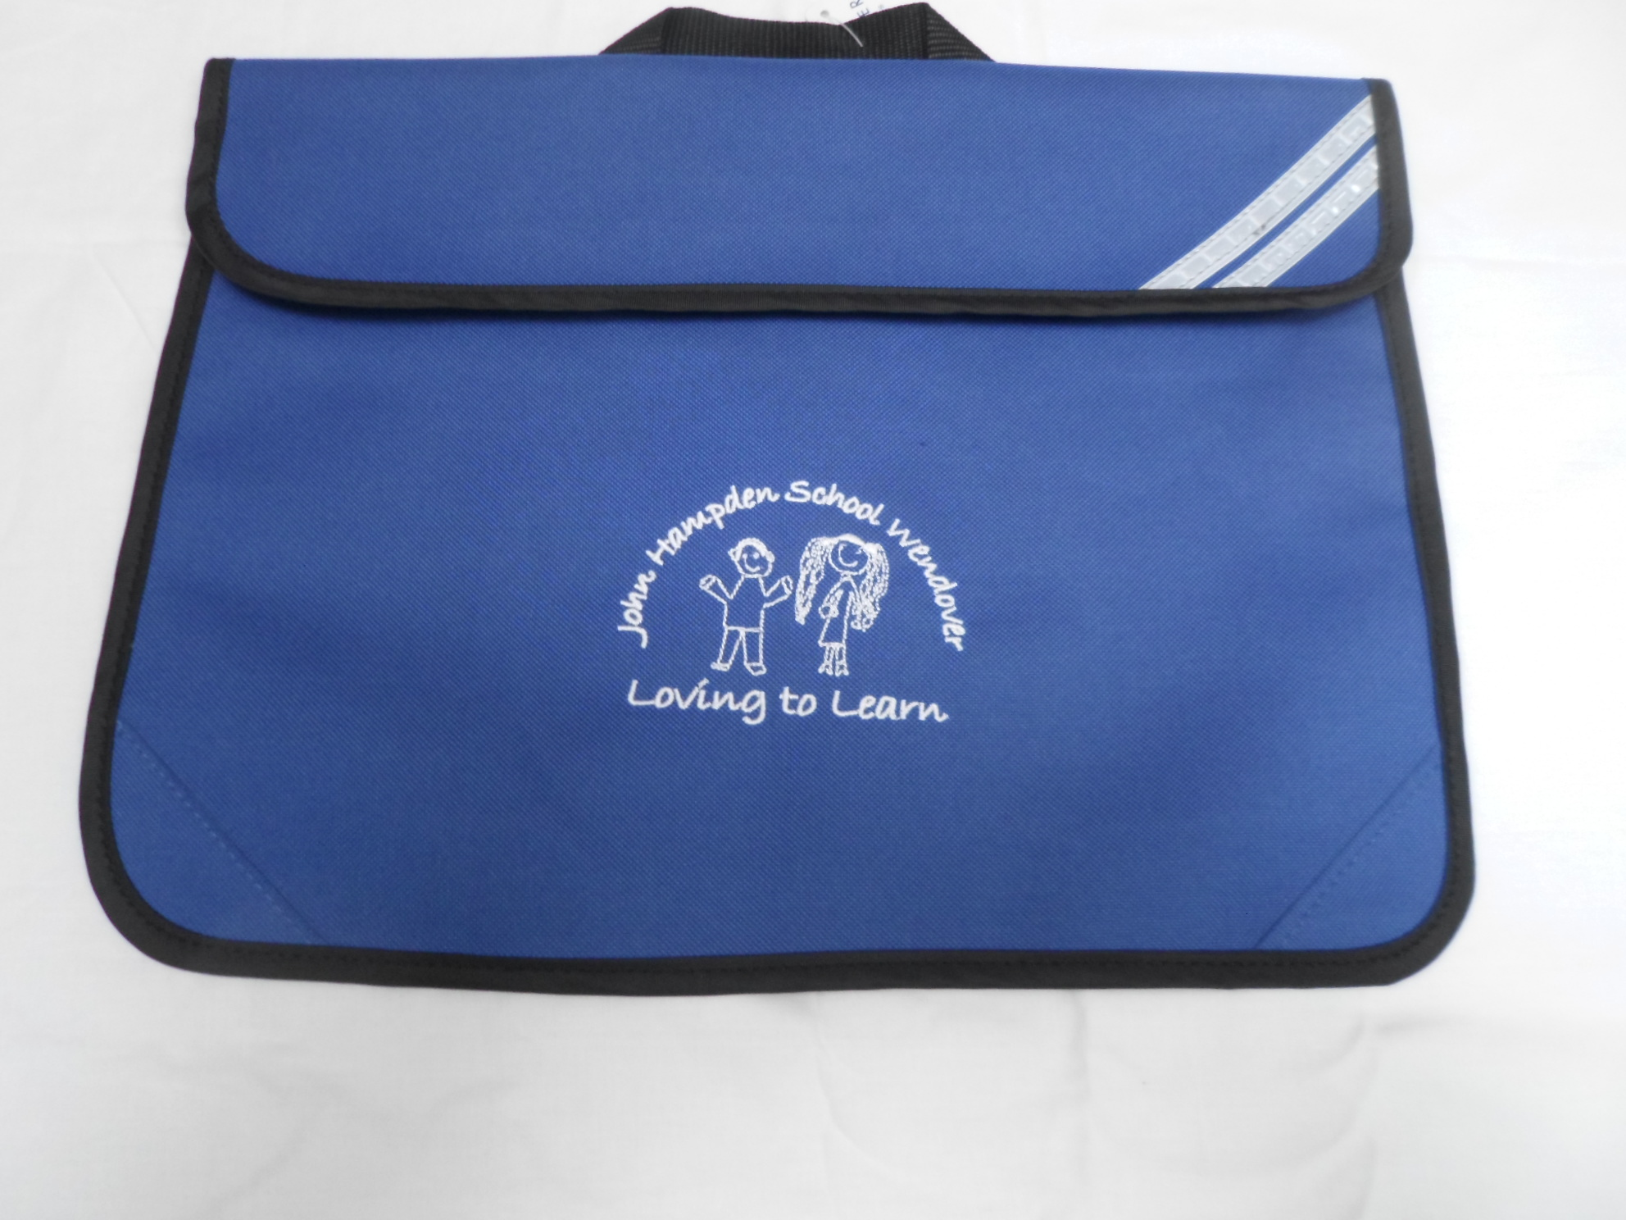 | £6.00
Woollen hat with logo (navy blue) – one size |  | 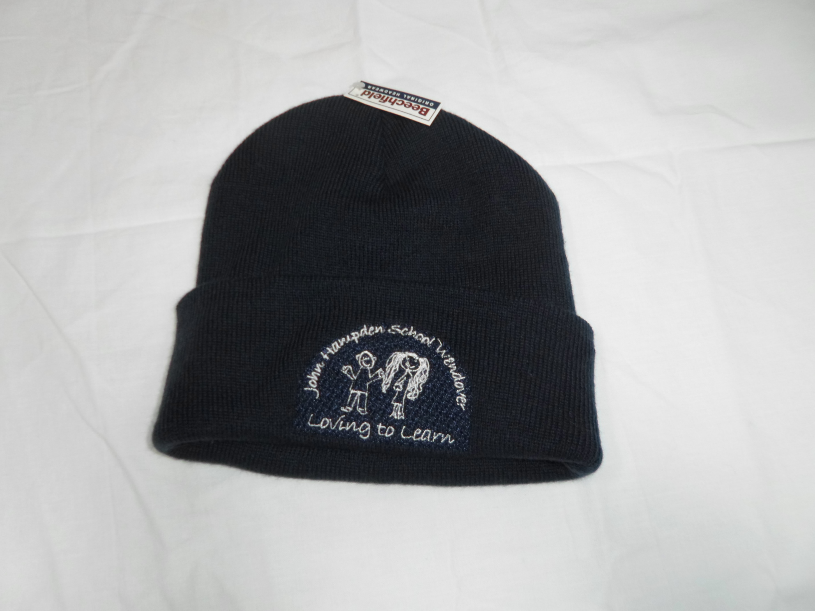 | £4.50
Baseball cap (red, royal blue, navy, yellow) |  |  | £6.00
 | TOTAL |  |  |  |  |  | £

PLEASE MAKE CHEQUES PAYABLE TO “BUCKINGHAMSHIRE COUNCIL” OR CONTACT THE SCHOOL OFFICE TO PAY ONLINE

