WB: 15.9.25 | Value: Collaborate | Behaviour Expectation: Do be kind and helpful
Question of the Week: What can we use our eyes and sense of sight for?

We will be reading the story:  How The Crayons Saved The Rainbow  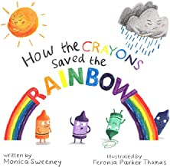 | Grandma’s Fantastic Words  happy cheerful delighted    sad unhappy miserable  Please use these words in a variety of different contexts and encourage children to use them for example:  I felt cheerful when I saw my grandparents at my birthday party.  I was miserable when my favourite toy broke and I couldn't play with it anymore. |  | Poetry Basket Poem  Leaves Are Falling  Leaves are falling, leaves are falling.  One fell on my nose.  Leaves are falling, leaves are falling,  One fell on my toes.  Leaves are falling, leaves are falling,  One fell on my head.  Leaves are falling, leaves are falling,  Yellow, Orange, Red. | O  dots  circling    Sing you are my sunshine
Curious Conversations:
Same/different
Phonics  Phonics  We will be playing oral blending games – saying touch your t-oe-s etc point to your b-r-ai-n .  We will be learning the spellings for the sounds:  s a t p  Each spelling for the sound has an action.  We will be learning to read the tricky word as and the high frequency word at  Please see Parents Phonics Newsletter for further details |  | Our value this week is -  Collaborate    To work with someone else, or a group, to achieve or do something  The children will demonstrate in a variety of ways different levels of collaboration throughout their learning this week including .  Our behaviour expectation this week is: Do be kind and helpful. |  | Tales Toolkit  We will be continuing to introducing Tales Toolkit symbols. This week we will focus on the problem and solution in the story. When the children see the problem symbol they say “But” and when they see the solution symbol they need to say “So”
   | 
  But | So

To answer the questions of the week What can we use our eyes and sense of sight for?, we will read ‘Brown Bear Brown Bear What Do You See?’ and then go on a ‘noticing walk’ looking for plants and flowers in different areas of the foundation stage garden and naming them, collecting natural materials. We will be sorting natural materials using simple properties.  Can you go on a noticing walk? What will you notice? If you want to take some pictures and share them with your teacher and friends.  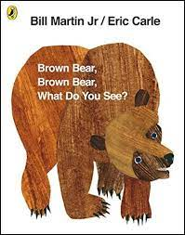 | - I know that directions can be followed and lead to different places  - I know that directions can be said, a picture or written down | In Maths we will be subitising. Subitising is being able to instantaneously recognise a number of objects in a small group without the need to count them.  What do you see? I can see 2.  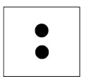  I can see 3  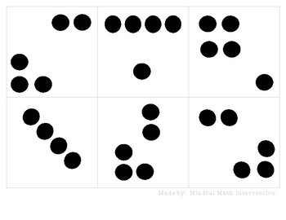  Collect some objects (up to 3) and rearranging in many ways asking What can you see? I can see 2. I can see 1. I can see 3.
Please share Library Book Club


