Summer 2 Week 2
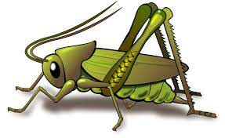
Question of the Week: World Week 1 - Where do I live? My local area – Wendover
Activities based on the interests of the children….
World Week  We will be developing a curious mind and learning about the world. We will start with our immediate location where we live, Wendover, then look at London and the UK. Continuing next week to learn about a different country.  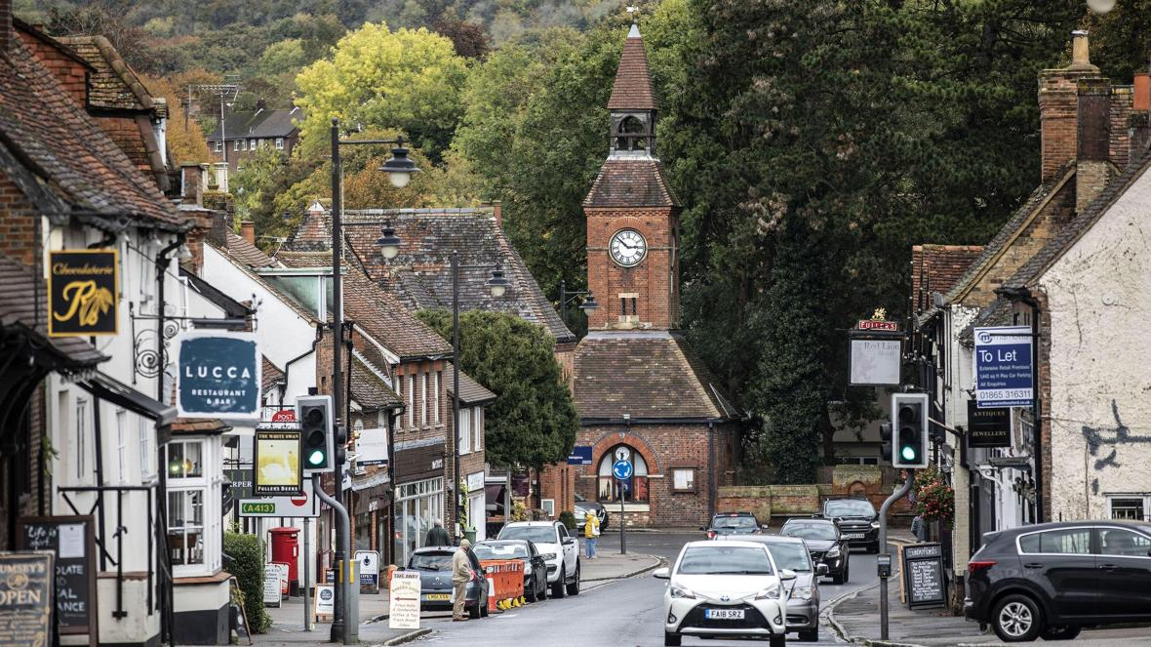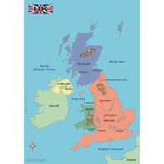    Conversation starters: What do you notice on your route to school? (streets, trees, shops, buildings, canal, clock tower…) | Poetry Basket    Our Poetry Basket Poem this week is;  Monkey Babies  Don’t leave your monkey baby sitting by a swamp.  A crocodile might eat him. Chomp. Chomp. Chomp.  Don’t leave your monkey baby sitting in the breeze.  A snake might wrap around him. Squeeze. Squeeze. Squeeze.  Don’t leave your monkey baby sitting on the track.  A lion might be lurking. Snack. Snack. Snack.  Keep your monkey baby high up in the trees,  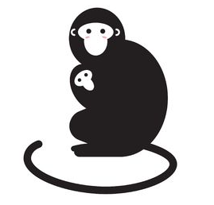  Feed him on bananas and pick off all his fleas. | Our Rhymes  Our Number rhyme this week is ‘Baa Baa Black Sheep’  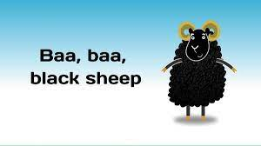  Our Number rhyme is ‘5 Little Monkies’  
Maths  We will be consolidating all our number and maths skills this half term. This week we will also be describing routes from A to B. We will be developing related to direction. (forward, behind, between, in front of, over, near, far)  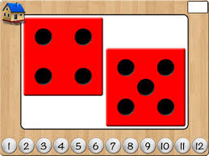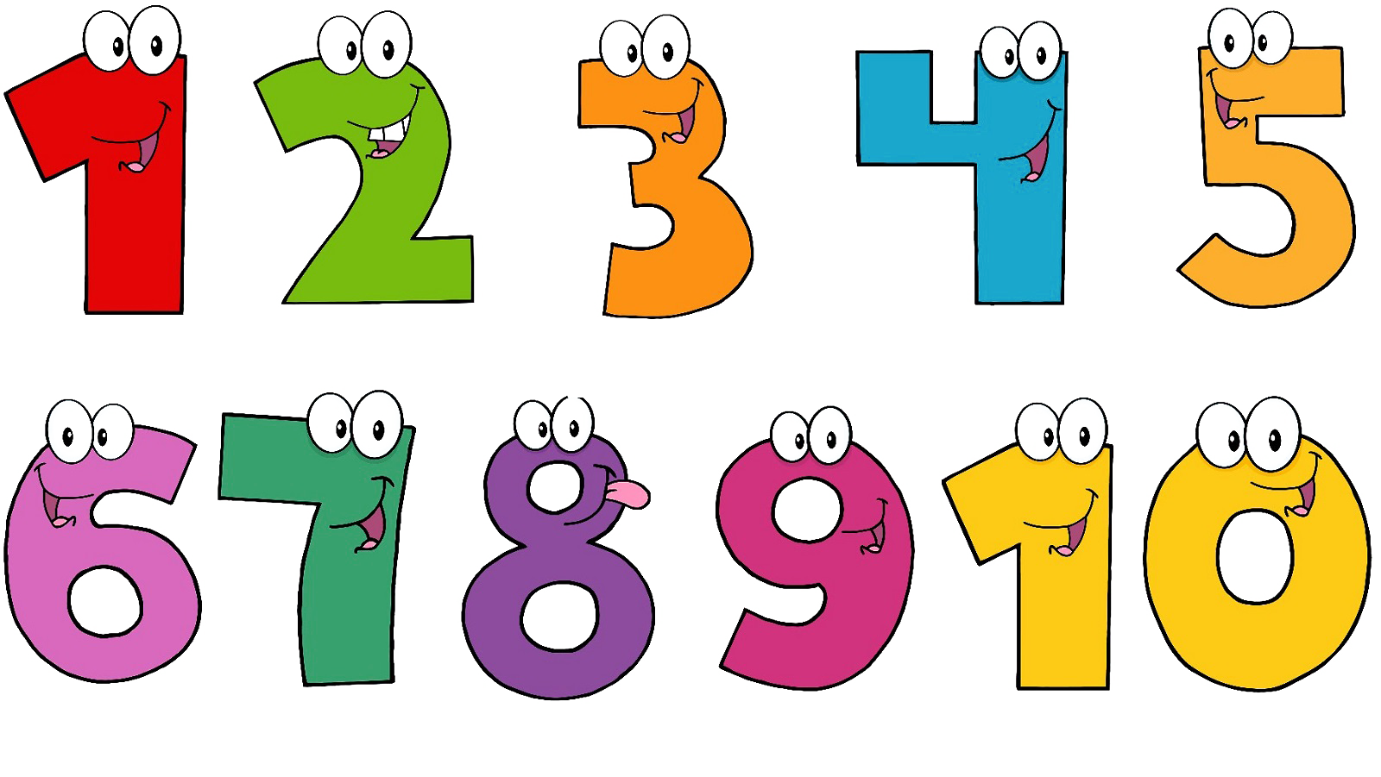 | Our story  Our Core Text this week will be The Gingerbread Man .  We will follow the gingbread man to different locations.  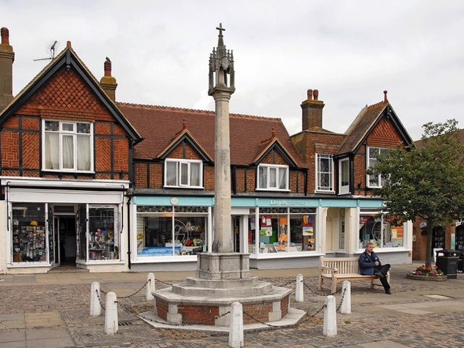  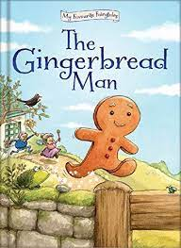    We will be story telling using story maps. | Phonics  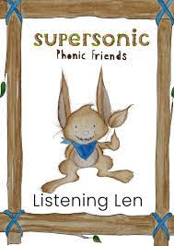  We will be embedding our phonological knowledge learnt so far. We will be doing lots of oral blending and playing fun phonics games.  