9.11.26  Our question of the week is:  Why do we remember special occasions?  Our value this week is:  Perseverance  Poem we are Learning:  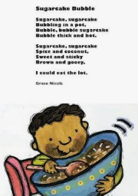  ‘Sugarcake Bubble’ by Grace Nichols | ENGLISH  Last Stop on Market Street  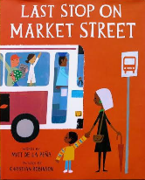  This week we will be learning to use noun phrases in our writing and beginning to plan our own stories  HANDWRITING  Practising the letter formation families and 18 eighteen.  PHONICS  Y2 Spelling Rules: Change the /y/ to an /i/ and add /er/  READING  Daily Story Sessions & Learn a Poem.  Remember to bring in reading books and diaries every day. Please sign the diary when you have heard your children read. | MATHS  Number  Representing Number  We will be exploring ways to represent two-digit numbers using concrete and pictorial representations  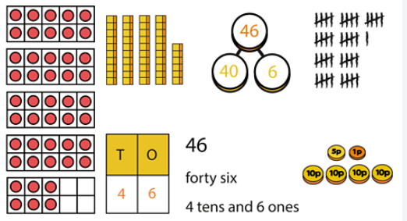 | PE  Multi Sports  
ART  Water colours and Mark Making  We will be using water colours in combination with mark making  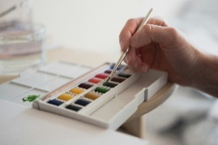 |   Water Safety Assembly   | MUSIC    To move in time to the pulse and practising our nativity songs  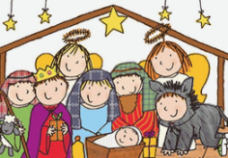 | SCIENCE  Investigation: Floating Boats  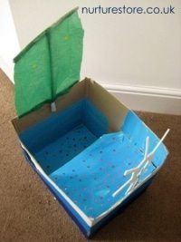
 | RE & History  We will be learning about Remembrance in our History lesson and will be thinking about special occasions we spend with out families   | COMPUTING  Learning what an algorithm is and how to programme an algorithm using Scratch.   |   Your homework books look FANTASTIC! Your first assignment will be sent out on Thursday 12th November. Please see the success criteria inside the homework book which will inform you of the task and when it is due in.

