PE  Sports Day Practise & Day / Athletics  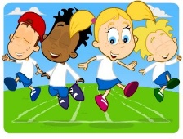  Mindful minutes | ENGLISH  Narrative: Superhero Stories  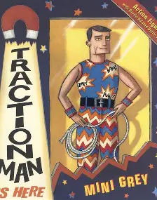  The children will listen to Superhero Stories. They will create a character description by building layers of description including, adverbs, expanded noun phrases complete with appropriate punctuation.  SPAG / HFW / TW / CEW. Reading comprehension / Guided Reading - Fiction / Non-Fiction  HANDWRITING  Introduction to horizontal joins  PHONICS  Daily Phonics Sessions.  READING  Daily Story Sessions & Learn a Poem.  Remember to bring in reading books and diaries every day. Please sign the diary when you have heard your child/ren read. | 22.6.26  We will continue to focus on our school Behaviour Expectations & Values.  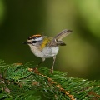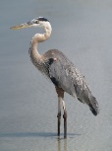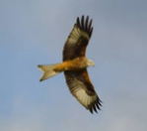  We will be reading:  Superhero stories, Non-fiction & Poems  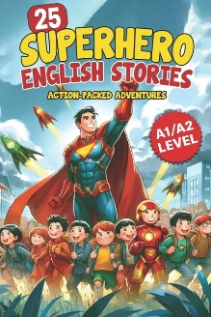  SPELLINGS  Please help the children to practise their High Frequency and Common Exception Words | MATHS  Measurement: Capacity  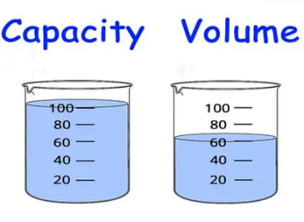  If you have time at home could you please have a go at telling the time with your child/ren, o’clock, half past, quarter past and quarter to. Plus 5 minute increments. | MUSIC  Practising our performance songs  
COMPUTING  Safe Searching, Photography and Pictograms in Computing Lessons.  ART  Clay mini beasts painting.  Sewing and mark making dragonflies.  DT  DT planning farm vehicle painting boxes. |  |  | SCIENCE  The children will be learning about Living Things & Habitats. They will be applying their skills to identifying different micro habitats and discussing why the minibeasts live where they do.  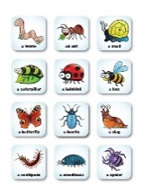
PSHE  Behaviour Expectations & Values  Reflection  Circle Time  Leaves - Reflection   |  | Homework    New homework was issued on 18.6.26 and needs to be returned on 30.6.26. The children’s homework is related to our Science Topic on Living things and habitats.  Any writing should be done in pencil and pieces should use up to 2 pages. This homework will also require a ruler. Please continue to support your child/ren during the task and encourage them to take their time and think about the presentation of their work. | FINE & GROSS MOTOR  Further developing of cutting skills.  A range of fine & gross motor skills.  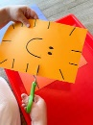  Trip  Herons and half of Firecrests. 22/06/26  Red Kites and half of Firecrests 30/06/26

