Question of the Week: Which animals make good pets?
WB: 10.03.2025
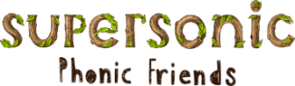  This week we will be revisiting the sounds  j, v, w, x  y, z, zz, qu  Tricky and High Frequency Words  her, was, you, will, he she we be, me | In handwriting, we will be continuing to practise forming the letters we have been learning. Our focus will be l, i and t, Len’s Long Ladders.  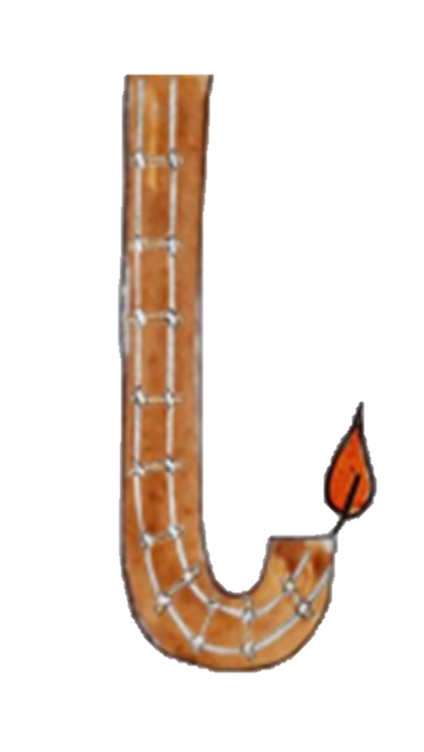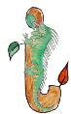  We will be recognising which letter family the letters come from and saying the ditties as we practice them! |   In Writing we will be learning to write instructions and character descriptions.  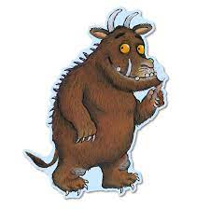 | Maths  The children will be exploring positional language. They will be learning and understanding the words in, on, under, up, down, across, in front of, behind, forwards, backwards.  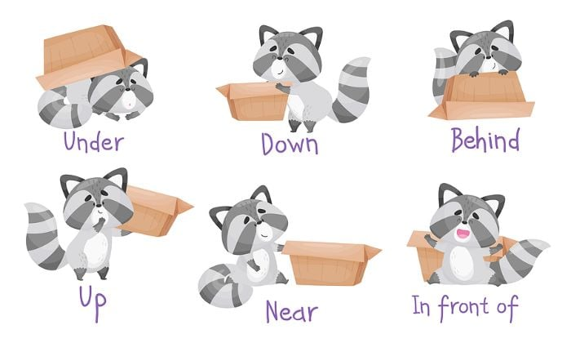
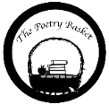  Wise Old Owl  A Wise old owl sat in an oak,  The more he heard, the less he spoke.  The less he spoke, the more he heard.  Why aren’t we all like that wise old bird?  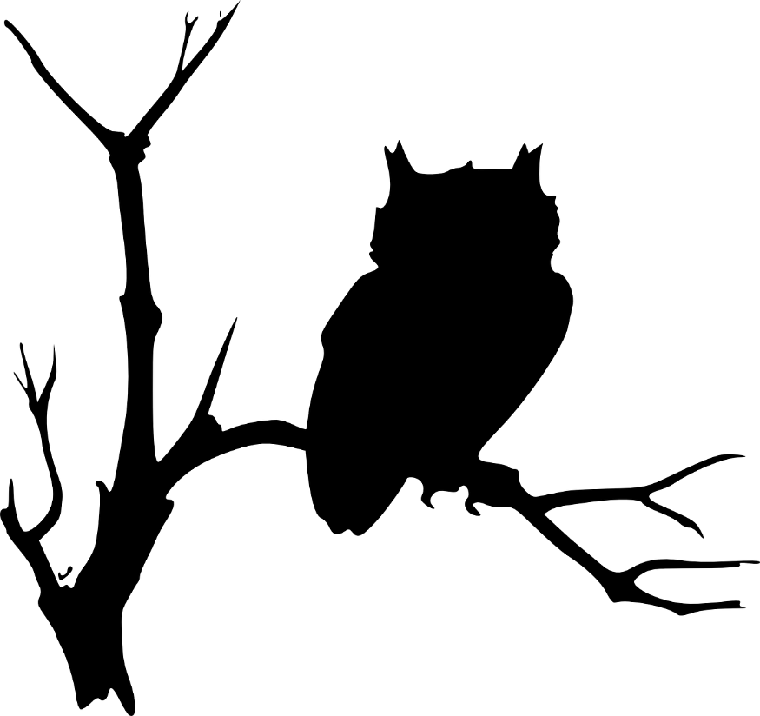 | We will be reading  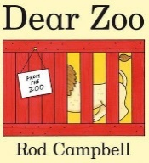  We will be using the ‘Explorify Webiste to develop childrens langauge and communication skills through scientific discusion through the Zoom in Zoom activity. Can children quess what it is?  We will also be thinking philosophically to think about what animals do and don’t make good pets?  What you rather have a goldfish or a pirahna? Can you say why? | Reading  Just a reminder, please ensure you hear your child read every day. This can be with their tricky words, high frequency words, sounds, reading books and poems.   | Wednesday  Animal Workshop  We are lucky to have our ‘Animal Workshop’ next Wednesday where the children will have the opportunity to see and hold a variety of animals. We are sure they will be excited to share their learning with you.  