WB: 2.2.26 | Value: Respect | Behaviour Expectation: Do look after property
Questions of the Week: What do you think is beyond the sky?

We will be reading the story:  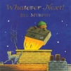 |   Grandma’s Fantastic trip journey expedition/ adventure/ voyage  We will be discussing space travel, talking about astronauts and watching the first Moon landing.   | Poetry Basket Poem  Climb aboard the spaceship, We’re going to the moon. Hurry and get ready, We’re going to blast off soon. Put on your helmet, and buckle up real tight. Here comes the countdown, Let’s count with all our might – 10.9.8.7.6.5.4.3.2.1. BLAST OFF! | Tales Toolkit  We will be continuing to create class Tales Toolkit using symbols. We will be substituting But for Unfortunately and So for Fortunately Can you make up a story at home? Remember to use the sentence starters
   | One upon a time/ A long time ago there was a ……. who lived in …………  One day……  Unfortunately …..  Fortunately …..  Snip snap snover, the story is over. Snip snap snout the story is out/ Tap the nail the nail bends, this is how the story ends.
  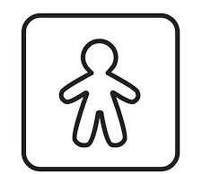
  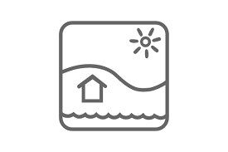
  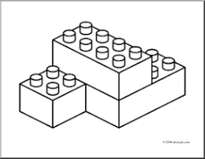
  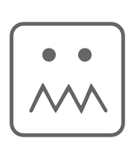
  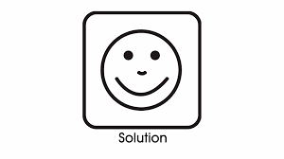
Curious Conversations:
Would you rather live in space or underground? Imagine how that feels. (Just Imagine)

Phonics  We will be learning to write the spellings for the sounds:  oo oo ar or  We will be learning to write the High Frequency Words too, look, for and Tricky words: some, come Please see Home Learning for further details | We are continuing to explore the properties of SOLID (3D) shapes  