WB: 4.11.24 | Value: Belonging | Behaviour Expectation: Do look after property
Question of the Week: How can I keep myself safe?

Our core text is :  Beware Of The Bears by Alan McDonald  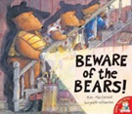  https://www.youtube.com/watch?v=2IR3QRMkqyA | Grandma’s Fantastic Words    ordered  told ordered commanded | Phonics  We will continue to hear syllables in words.  We will be learning to write the spellings for the sounds:  s a t p  We will be learning to spell the tricky word as and the high frequency word at  Please see Phonics sheet for further details
We will be learning about E-Safety with Mrs Shrimpton.  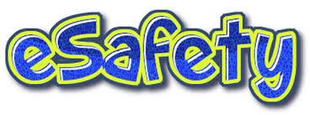 | We will be looking at information books about people who help keep us safe.  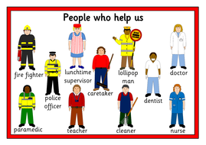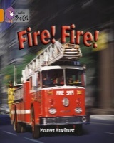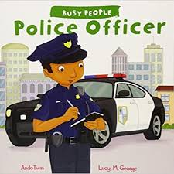 | We will be drawing fire engines and making maps.  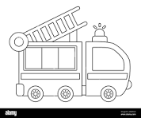
We will be learning about how to keep ourselves safe around fireworks, especially on Bonfire Night.   | We will be learning about road safety and meeting the local Police Officers.  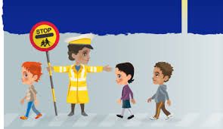 | : Please share Library Book Club book  

