PE  A focus on multi skills including co-ordination, balance, agility, teamwork and safety.  Christmas Dance  Mindful minutes  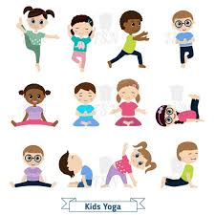 | ENGLISH  Narrative ‘The Hungry Badger’: Identify the features, Drama /Role Play using Tales Toolkit & Talk for Writing, writing the story & planning character descriptions.  HANDWRITING  Number Handwriting and words containing Curly Cal, Lens Ladder or Zig Zag Letters  PHONICS  Daily Phonics Sessions  READING  Daily Story Sessions including Helicopter Stories, Tales Toolkit Stories and Talk for Writing & Learning Poems.  Remember to bring in reading books and diaries every day. Please sign the diary when you have heard your child/ren read. | 17.11.25  We will continue to focus on our school Behaviour Expectations & Values.  We will be reading:    The Hungry Badger | MATHS  Number  Place value, Representing Numbers  Using a variety of manipulatives to represent a given number.  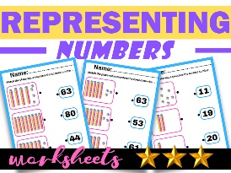 | MUSIC  Songs & rhymes  Christmas songs  
COMPUTING

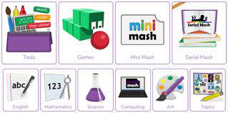

ART/CRAFT  Christmas calendars   | PSHE    Behaviour Expectations & values  Growth Mindset | ACTIVITIES AT HOME  Perhaps your child/ren could do the following at home:  - Visit Roald Dahl Museum in Aylesbury or Great Missenden  - Read Roald Dahl Books  - Watch Roald Movies  - Write a Tales Toolkit story  - Use mark making and pencils / paints to complete a piece of art  - Draw a picture in the style of Quentin Blake | HOMEWORK    New homework was issued on 6/11/25 and needs to be returned by 18/1125.  They need to create a homework linked to Firework Safety.  New homework will be issued on 20/11/25 and will need to be returned on 2/12/25. This will be on the weather. | FINE & GROSS MOTOR  Funky Fingers:  Cutting Skills  Crossing the mid-line  
HISTORY
Roald Dahl.
Focus on a significant local person, facts and chronological order
