Question of the Week: Which animals make good pets?
WB: 09.03.2025
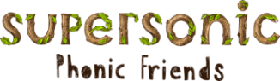  This week we will be revisiting the sounds  ai, ee, igh, oa  oo,oo, ar,or  ur, ow, oi, er  Tricky and High Frequency Words  Practise of all tricky words and high frequency words taught | In handwriting, we will be continuing to practise forming the letters we have been learning. Our focus will be u,y and j, Len’s Long Ladders.  Please remember to use the Padlet to check correct letter formation |   In Writing we will be learning to write instructions and character descriptions.  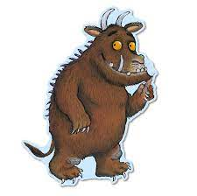 | Maths  The children will be exploring positional language. They will be learning and understanding the words in, on, under, up, down, across, in front of, behind, forwards, backwards.  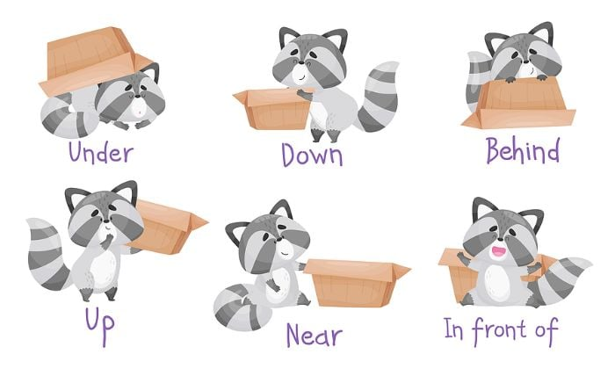
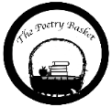  Wise Old Owl  A Wise old owl sat in an oak,  The more he heard, the less he spoke.  The less he spoke, the more he heard.  Why aren’t we all like that wise old bird?  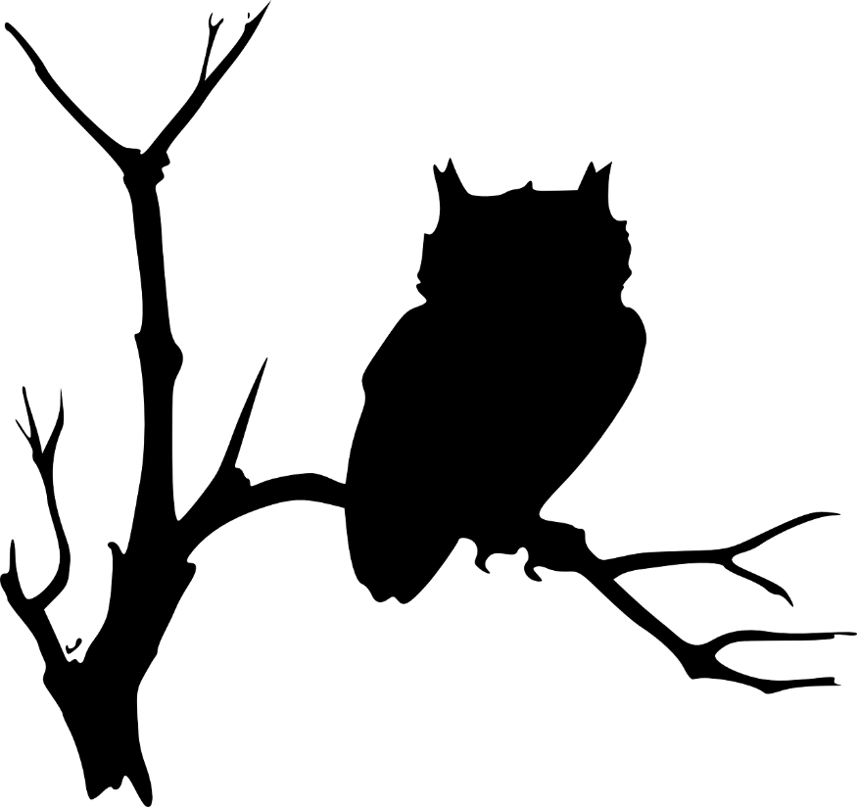 | Reading  Just a reminder, please ensure you hear your child read every day. This can be with their tricky words, high frequency words, sounds, reading books and poems.   | We will be reading  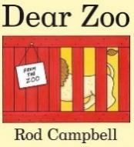  We will be using the ‘Explorify Webiste to develop childrens langauge and communication skills through scientific discusion through the Zoom in Zoom activity. Can children quess what it is?  We will also be thinking philosophically to think about what animals do and don’t make good pets? What you rather have a goldfish or a pirahna?  Can you say why?

