PE  Gymnastics  Mindful minutes  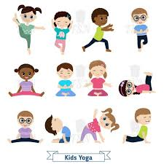 | ENGLISH  Writing Recounts  HANDWRITING  12, twelve  A, a  PHONICS  Daily Phonics Sessions  READING  Daily Story Sessions including Helicopter Stories, Tales Toolkit Stories and Talk for Writing & Learning Poems.  Remember to bring in reading books and diaries every day. Please sign the diary when you have heard your child/ren read. | 15.9.25  Our value this week is:  Collaboration  We will be reading  The Enormous Turnip  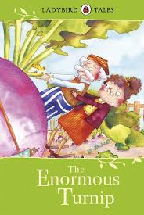 | MATHS  Number  Finding 10 more / 10 less.  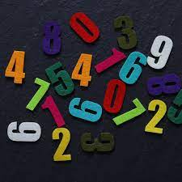 | MUSIC  Songs & rhymes, including Harvest songs  
COMPUTING



E-safety & Laptops
ART/CRAFT  Mark Making  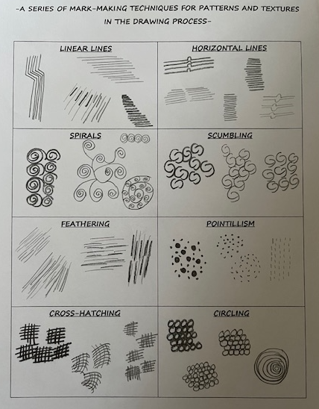 | PSHE  Story Lost & Found  Link to Collaboration  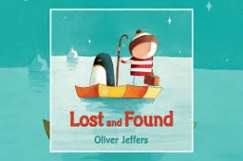 | SCHOOL VALUE ACTIVITIES AT HOME  Perhaps your child/ren could do the following at home to model Collaboration:  Help with household chores e.g. lay the table, washing up  Write a shopping list together  Estimate the cost of the shopping list  Make breakfast, lunch or dinner together  Help with gardening chores e.g. pick up leaves  Shared reading – share a book | GEOGRAPHY  Children will continue to learn about UK: England, Scotland, Wales, Ireland.   | FINE & GROSS MOTOR  Funky Fingers:  Cutting Skills  Crossing the mid-line  

