Question Of The Week: What happens when we mix primary colours? WB: 27.11.23
We will be continuing to learn about what happens when we mix primary colours with white or black.  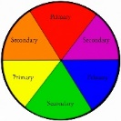  The terms ‘primary’ and ‘secondary’ will be introduced and the children will be encouraged to explore and experiment different ways to make colours. | Science Experiment  As part of our learning about colour we will be engaging in a Rainbow Skittles science experiment to discover what happens when we add water to a circle of skittles (sshh keep it a surprise from the children).  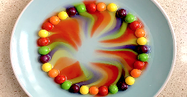 | Handwriting  We will be practicing writing the correct letter formation for h, b, l, f  We will be also be practicing writing tricky words, words and short captions and sentences e.g hen, bat, a hen sat, It is a hen.
  In Supersonic Phonics we will be learning the spellings for the sounds  h, b, l, f  We will continue to learn ‘High Frequency Words’ up, mum, put, get  and practicing reading and writing ‘Tricky Tess’ words  I, is, a, to, the , no, go, his, her, has, a | Baking Bread  We have been learning the story ‘The Little Red Hen’ and we are going to be following a recipe to make bread rolls.  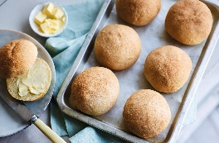 | Maths  In Maths we will be continuing to engage in activities to focusing on composition. We will be looking at ways to compose 3 and 4 in different ways and talking about part and whole models.
Light and Dark  We will continue our learning on light and dark and look at different materials including those that reflect light. We will be looking at different objects and  learning that shiny objects need a light source if they are going to shine but that shiny objects are NOT light sources  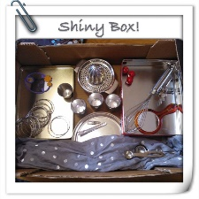 | Christmas play  Preparations and practicing is going well for our Christmas Nativity Play. Hopefully children will be singing the songs and doing the actions for you at home.  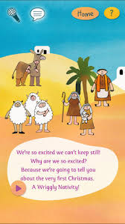  Please bring your child’s costume in a named carrier bag on Thursday 30th November. | Inset day  Friday 1st December. The school will be closed to pupils on this day.  Parents Tips and reminders  Please ensure children bring their reading folder into school every day. These will then be changed on a Friday.

