English  This week we will be writing our own sentences using a capital letter, finger spaces and full stop. | Maths  This week in Maths we will be looking at part, part whole models for numbers up to 10. | PE  Our focus in PE in this half term will be multi-skills Please ensure your child has a full, named PE kit including joggers.
Music  We will be rehearsing songs ready for our Christmas Nativity. | Week beginning 19.10.25  Incredible Me!  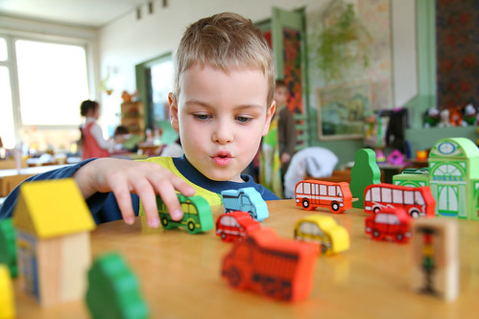 | Science  We will be investigating different senses.
Poetry  We will be looking at classic Poems from our “Poetry Basket”. |  | Art  This half term we are going to be looking at sketching and mark making in Art and using H and B pencils to create different effects.
 | PSHE  This half term we are focusing on safety at home. This week we will start thinking about what is/is not an emergency. | Geography  We will be researching our local area and looking at it on a map.
Phonics
We will be recapping and reviewing Basics 4 and reading CVCC words.

