SAFETY WEEK – YEAR TWO

Monday 31st October |  | We will meet Mrs West, the School Crossing Patroller, who will talk to us about Road Safety |  | We will have a ‘Stay Safe’ assembly  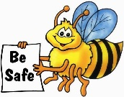 |  | We will learn how to cross the road safely with Junior Road Safety Officers from Wendover Junior School  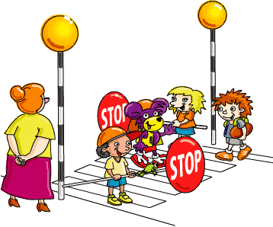 |  | At other times during the week, also linked to Safety Week, we will learn about:  - How to enjoy Halloween safely  - Medicine safety  - Stranger Danger  - Risk and Danger  - What would happen if…  - Resilience  - Safety through P4C
Tuesday 1st November |  | We will have a safety talk from two police officers |  | We will have an anti-bullying assembly with Mrs Barnes |  | We will learn about bicycle safety
Wednesday 2nd November |  | We will meet Mr Nelson – a paramedic |  | We will learn about e-safety with Miss Nawaz  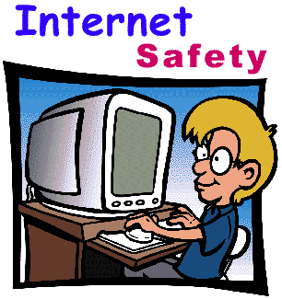
Thursday 3rd November | We will learn about safety around dogs in an assembly |  | We will learn about water safety with Liz Ward  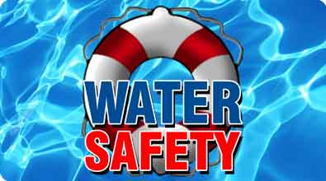 |  | We might learn about medicine safety today |  | We will have a ‘Taking Care of Myself’ Assembly
Friday 4th November | We will learn about Firework Safety |  | We will learn about Fire Safety  