English  We will be using our writing skills and producing our own writing in provision. | Maths  We will be working on place value and completing practical activities. | PE  Our focus in PE in this half term will be multi-skills Please ensure your child has a full, named PE kit including joggers as we will sometimes be outside.
Music  We will be exploring musical sounds and how they can be changed focussing on timbre, dynamics and pitch. | Week beginning 23.3.26  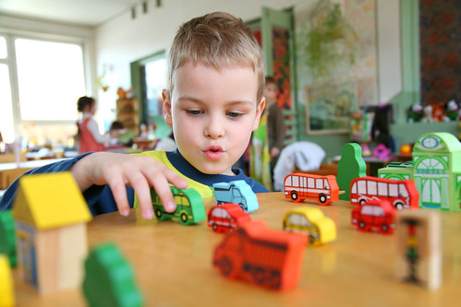 | Science  This week we will be looking at amphibians and reptiles and their features. How do we know why they fit into each category?
Poetry  We will be looking at classic Poems from our “Poetry Basket”.  This half term our poems are “Space” |  | DT  This week the children will be designing and making their own royal item. Please bring any cardboard in you have spare.
 | PSHE  This half term we are focusing on friendships, diversity and communities.  Our value of the week is independence. | History  We will be looking at different kings and queens that have ruled England in the past.
Phonics
We will be working through the Switch it Mitch sounds and tricky words.

