PE  Athletics  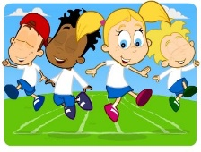  Mindful minutes | ENGLISH  Narrative: Superhero Stories    The children will continue to listen to Superhero Stories. They will continue to create a character description by building layers of description including, adverbs, expanded noun phrases complete with appropriate punctuation.  SPAG / HFW / TW / CEW. Reading comprehension / Guided Reading - Fiction / Non-Fiction  HANDWRITING  Introduction to horizontal joins  PHONICS  Daily Phonics Sessions.  READING  Daily Story Sessions & Learn a Poem.  Remember to bring in reading books and diaries every day. Please sign the diary when you have heard your child/ren read. | 6.7.26  We will continue to focus on our school Behaviour Expectations & Values.  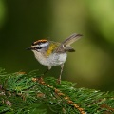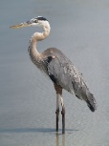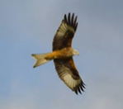  We will be reading:  Superhero stories, Non-fiction & Poems  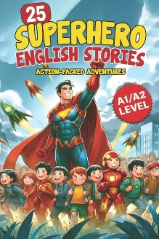  SPELLINGS  Please help the children to practise their High Frequency and Common Exception Words | MATHS  Measurement: Mass  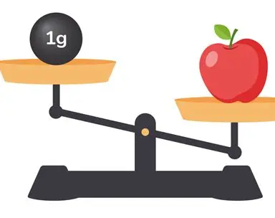  If you have time at home could you please try to measure mass perhaps when you are cooking or baking. | MUSIC  Practising our performance songs!  
COMPUTING  Safe Searching, Photography and Pictograms in Computing Lessons.  ART  Clay mini beasts painting.  Sewing and mark making dragonflies. |  |  | SCIENCE  The children will be learning about Living Things & Habitats. They will be applying their skills to the pond they visited at the Eco-Garden.  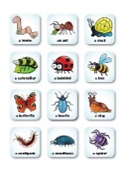  TRIP  Year 2 will go on a trip to the Eco-Garden looking at sustainability.  TRANSITION DAY  The children will visit their new teachers.
  Behaviour Expectations & Values  Reflection  Circle Time  Leaves - Reflection    RE  Creation stories across different religions.  Part 2 |  | Homework    New homework was issued on 2.7.26 and needs to be returned on 14.7.26. The children’s homework is to write a letter to their new teacher. Please see the example letter included and complete on the paper provided, neatly and in pencil. | FINE & GROSS MOTOR  Further developing of cutting skills.  A range of fine & gross motor skills.  