English  This week we will be looking at instructions. What are instructions and looking at examples. The children will then be writing their own instructions. | Maths  This week in Maths we will be using the more than and less than symbols to compare numbers. | PE  Our focus in PE in this half term will be multi-skills Please ensure your child has a full, named PE kit including joggers.
Music  We will be rehearsing our Harvest Festival Songs. We will be thinking about using our voices to create an effect. | Week beginning 21.09.25  Incredible Me!  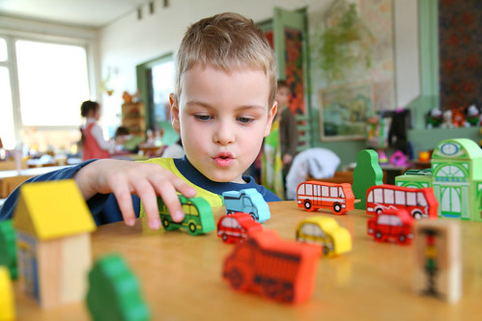 | Science  Animals and Humans  We will be thinking about the amazing human body. We will be looking at naming and labelling different parts of the body.
Poetry  We will be looking at classic Poems from our “Poetry Basket”. |  | Art  This half term we are going to be looking at sketching and mark making in Art and using H and B pencils to create different effects.
 | PSHE  This half term we are focusing on safety at home. This week we will start thinking about what is/is not an emergency. | Geography  Next week we will be reading ‘Martha Maps it Out’ and thinking about our local geography and where we live.
Phonics
We will be recapping and reviewing Basics 4 and reading CVCC words.

