Summer 1 Week 2
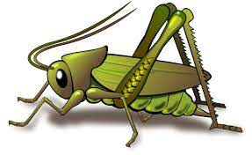
Question of the Week: What do you know about the earth and space? What is it like on the Moon?
Activities based on the interests of the children….
This week’s story is Dinosaur Rocket by Penny Dale  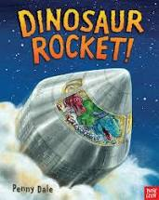  No longer content with building, or zooming, or even rescuing, the dinosaurs now have their sights set on something much, much bigger - the moon. The fearsome friends prepare for their cosmic journey: is the rocket all ready? Will the launch go smoothly? Can they make it to the moon - and back again?  We will be talking about space travel, the moon and being brave in adventure.  Ask your children what new vocabulary they have learnt. |   Our Poetry Basket Poem this week is;  I Have a Little Frog  I have a little frog,  His name is Tiny Tim,  I put him in the bathtub,  To see if he could swim.  He drank up all the water,  And gobbled all the soap.  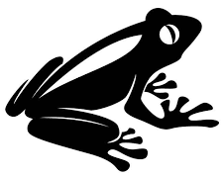  And when he tried to talk,  There were bubbles in his throat. | Conversation starter ‘What would it be like on the Moon?  We will be talking about the Earth and Space, singing Space songs and rhymes, constructing and drawing rockets and creating space pictures. We will be thinking about 2D and 3D shapes. We will be Moon walking and talking about gravity.  We will be singing the Nursery Rhyme ‘Twinkle Twinkle little star’  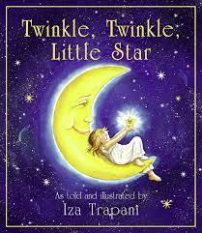
Our Number rhyme this week is ‘5 Little Men in a Flying Saucer’. We will also be singing Twinkle Twinkle Little Star and Zoom Zoom Zoom...We’re Going to the Moon.  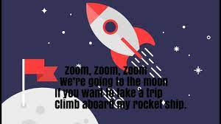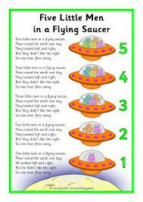 | The children will role - play being astronauts and construct/build rockets. They will be encouraged to plan, build and describe their constructions.  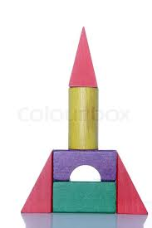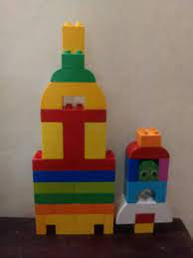  They will be encouraged to draw freely from imagination. | 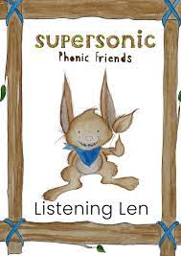  We will be embedding our phonological knowledge learnt so far. We will be doing lots of oral blending and playing fun phonics games.  