English  This week we reading the ‘Everywhere Bear’ and writing a recount. | Maths  We will be looking at looking at the number 20 and what two numbers make 20, on a number line and one more and one less than 20. | PE  Our focus in PE in this half term will be multi-skills Please ensure your child has a full, named PE kit including joggers as we will sometimes be outside.
Music  We will be exploring musical sounds and how they can be changed focussing on timbre, dynamics and pitch. | Week beginning 12.1.26  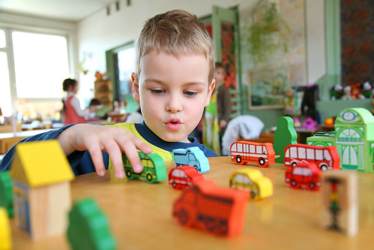 | Science  This week we will be looking at recording the properties of materials using a table.
Poetry  We will be looking at classic Poems from our “Poetry Basket”.  This half term our poems are “Space” |  | Art  This half term we will be working on mixing of primary colours.
 | PSHE  This half term we are focusing on looking at feelings and how to regulate your own feelings. | History  This week we will start looking at a selection of new and old toys.
Phonics
We will be working through the choose to use sounds and tricky words.

