PE  Gymnastics  Mindful minutes  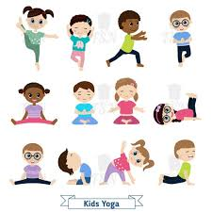 | ENGLISH  Writing Information Texts  HANDWRITING  Number Handwriting and words containing Curly Cal, Lens Ladder or Zig Zag Letters  PHONICS  Daily Phonics Sessions  READING  Daily Story Sessions including Helicopter Stories, Tales Toolkit Stories and Talk for Writing & Learning Poems.  Remember to bring in reading books and diaries every day. Please sign the diary when you have heard your child/ren read. | 7610.25  Our value this week is:  Independence  We will be reading  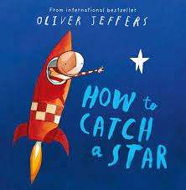  Oliver Jeffers | MATHS  Number  With a focus on Place Value  Place value Tens & One and Part, Part Wholes: showing numbers using abstract, pictorial and concrete representations.  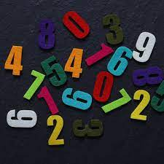 | MUSIC  Songs & rhymes  
 |  |  | SCIENCE  Children will be looking at Animals including Humans and their Basics Needs  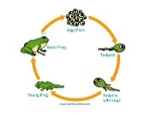 | COMPUTING    E-safety & Laptops
ART  Mark Making  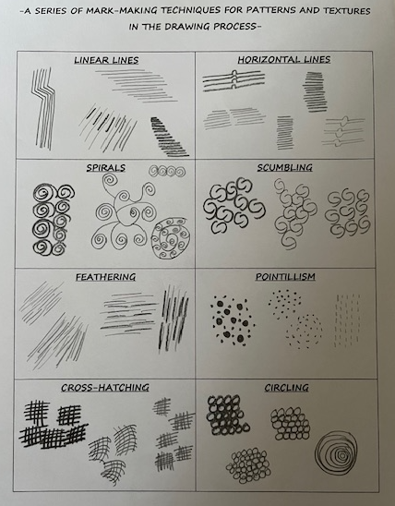  HISTORY  The children will be looking at some significant figures linked to Black History Month | PSHE    Books linked to Independence  When Cucumber Lost His Cool  Stuck  A Huge Bag of Worries  Calm Down Boris | SCHOOL VALUE ACTIVITIES AT HOME  Perhaps your child/ren could do the following at home to model Good Independence:  Eating at meal times with cutlery  Tying their own shoe laces  Packing & checking their own school bag  Tidy away  Completing a simple homework task | Homework  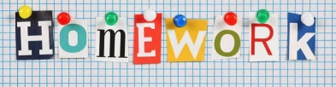  Children needed to neatly decorate their homework books.  Homework went out on 25/9/25 and needs to be returned by 7/10/25.  New homework will be issued on 9/10/25 and needs to be returned by 21/10/25.  They need to find and write and decorate their own autumn poem. | FINE & GROSS MOTOR  Funky Fingers:  Cutting Skills  Crossing the mid-line  