PE  Multi-Skills  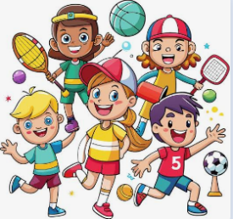  Playground Equipment Games  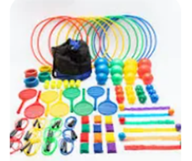  Focus: Good Manners | ENGLISH  How to Make Friends with a Ghost  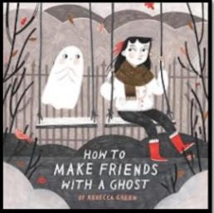  This week we will writing our own set of instructions for how to be a good friend.  HANDWRITING  Practising the letter formation families and 13 thirteen  PHONICS  Daily Choose to Use Phonics Sessions  READING  Daily Story Sessions & Learn a Poem.  Remember to bring in reading books and diaries every day. Please sign the diary when you have heard your child/ren read. | 28.09.26  Our question of the week is:  Why is exercise important for our bodies?  Our value this week is:  Respect  Our Behaviour Focus this week is:  ‘Do listen.’  Poem we are performing:  We are all different!  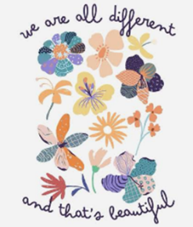 | MATHS  Number  We will be using the base 10 model to consolidate our understanding of place value.  27  2 tens and 7 ones  27 = 20 + 7  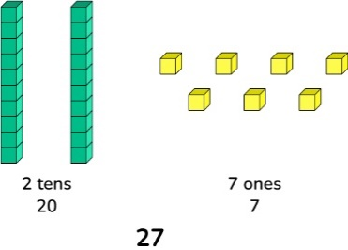 | MUSIC    To copy rhythmic patterns.  To create a rhythmic pattern based upon spoken words.  To play rhythms to a steady pulse.
COMPUTING
Coding
Understand what algorithms are.

Create and debug simple programs.

ART  Sketching and Mark Making  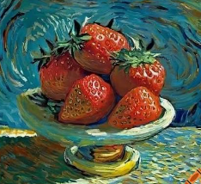  We will look how famous artists have used mark making to produce still life art. We will begin to recreate a picture of strawberries using our mark making skills. | PSHE  What does ot mean to be respectful?  Do listen  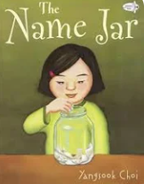   | Science  This week we will be learning about the importance of exercise.   |   Respect  Can your children complete the ‘Respect’ challenge and as a family, talk about this value and the importance of it.  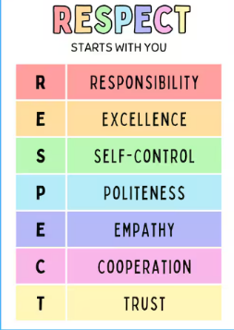 | Geography  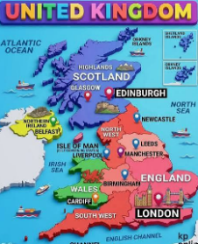  We will be learning about the four countries that make up the U.K.  This week we will be learning about England including capital city, national flower, highest mountain and longest river.

