WB: 01.12.25 | Value: Good Manners | Behaviour Expectation: Do be polite. Do be gentle.
Question of the Week: How can we make different shadows using light and objects?

We will be re-visiting the story:  The Day The Crayons Quit  By  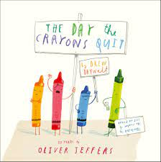  https://www.youtube.com/watch?v=gPkrhIEoOJg | Grandma’s Fantastic Words  Little not much not many  pile stack heap, mound,  bundle  Please use these words in a variety of different contexts. | Stories  We will be looking at some traditional tales – eg Rapunzel  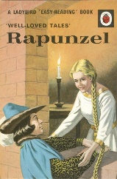 | Maths  In Maths we will be looking at properties of triangles and quadrilaterals.  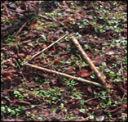
Curious Conversations:
What is your favourite colour?

My favourite colour is …
because…

Phonics  .  We will be learning to write the spellings for the sounds:  h, b, f, l  We will be learning to spell the tricky words has, his and as, and the high frequency words has, his, as  had, him, back, but, big, if  Please see Home Learning Phonics for further details | Our value this week is -  Good Manners  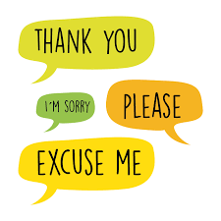  To treat others with courtesy and politeness and behave well towards them  The children will demonstrate in a variety of ways different levels of good manners throughout their learning this week, including .  Our behaviour expectation this week is: Do be polite. Do be gentle |  | Our Nativity  We can’t wait to share our Wriggly Nativity with you!  