Question of the Week: What are some of the UK’S most amazing and famous features and landmarks? WB: 1.6.26
  In Phonics, we will be learning how to read polysyllabic, e.g. sandpit,  lunchbox, windmill, paintbrush | In Handwriting, we will be continuing to perfect our John Hampden letter formation, ensuring all letters sit on the line and the tall letters to the top. |   In Writing, the children will be writing sentences about London as well as a recount of what the Gingerbread Man got up to.  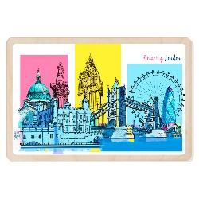 | Maths  In Maths, the children will be revisiting composition with numbers to 10 and practising doubles facts to 5.  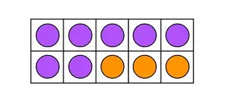
Curious Question  What kind of home would you choose and what would you put in it?  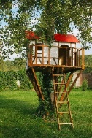  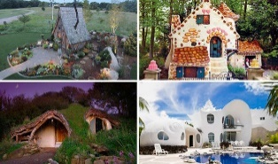 | 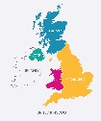  Our topic is Why is Our World Wonderful?  During Worlds Weeks we will be learning about the United Kingdom. By the end of this week, we will know that the United Kingdom is an island and that it is comprised of four countries.  We will also focus on the capital city London and  it’s famous landmarks.  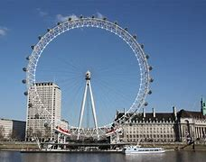  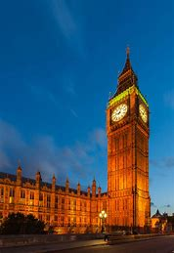  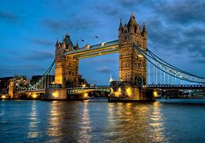 |  | 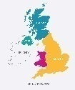  Parents Hints and Tips  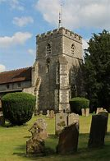    Reminder  Church Trip  Tuesday 17th June 2026  Coats & Sunhats  Please ensure children have a waterproof coat and a sunhat everyday. Please apply sun lotion if needed - dependent on the forecast.  We are outside regardless of the weather.

