Autumn 1 Week 3
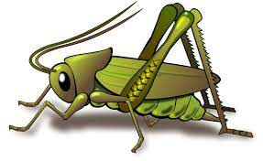
Value of the week: Collaboration
Activities based on the interests of the children….
Welcome to Crickets!  We are learning about the JHSW Values and Behaviour Expectations. We will be reading the story How the crayons saved the rainbow.  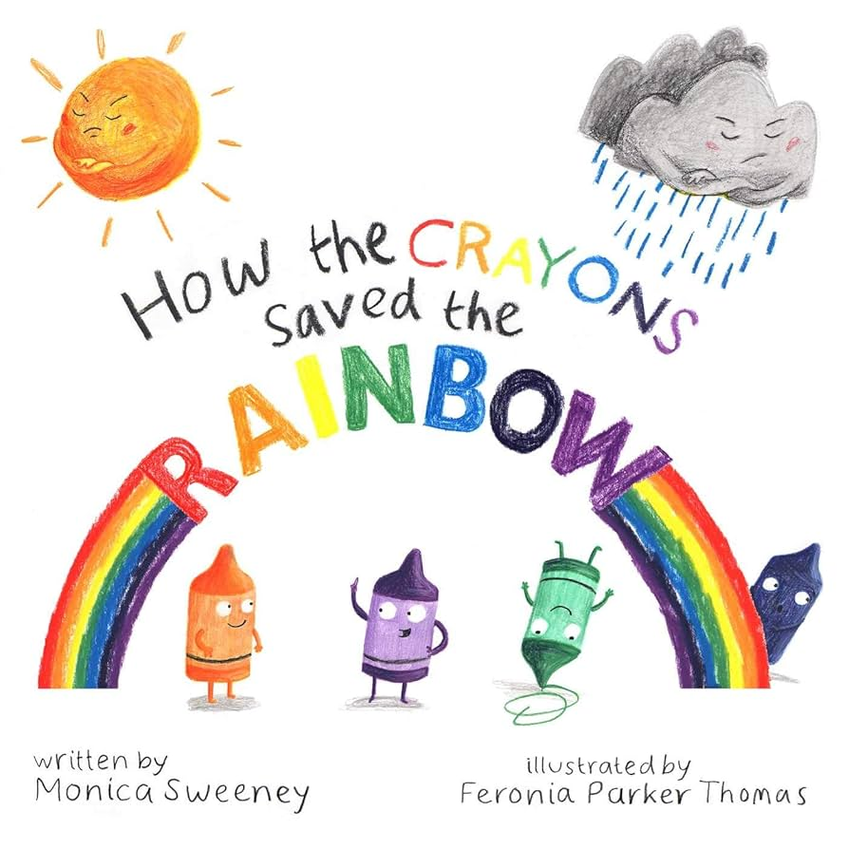  We will also be thinking about how we work together share and take turns. | Poetry basket  We will be listening to stories, rhymes and fairy tales.  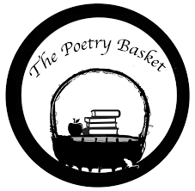  We will also be starting Poetry Basket, this is a special rhyme and movement activity. It is great fun and features a range of seasonal and classic poems.  Chop Chop  Chop, Chop, Choppity Chop.  Cut off the bottom and cut off the top.    What there is left, we put in the pot.  Chop, Chop, Choppity Chop. | All about me  Our aim is that all children feel happy, safe and welcome in Crickets. Each child is individual and their learning journey is unique.  This week we will be talking about ourselves and families and getting to know each other! We will be creating a self portrait of ourselves and talking about our likes and dislikes.  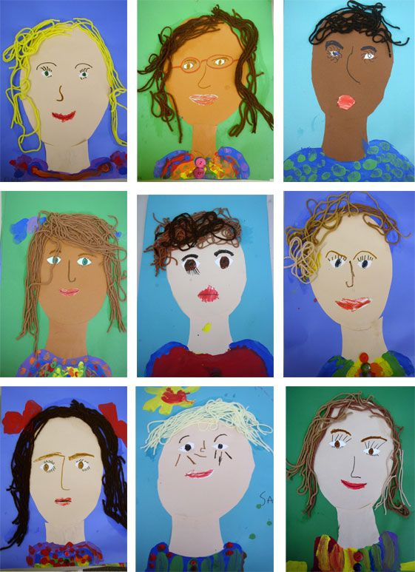
Maths  We will be doing lots of number rhymes and singing this week. We will be singing 5 little speckled frogs and 5 fat sauages.  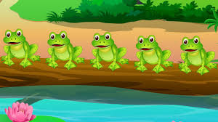 | Our value of the week  Our value this week is: Collaboration  Our behaviour expectation this week is: Do be kind and helpful.  We will be doing lots of learning based around working together and being kind and helpful.   | Mark making  We will be starting our mark making journey by making different marks inside and outside using big arm movements.  