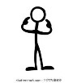
What We Are Learning Autumn 1 Week 7
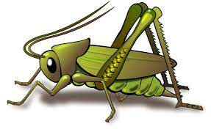
Value of the Week: Independence
Activities based on the interests of the children….
We are learning about the JHSW Values and Behaviour Expectations. We have already thought about being the best that we can be, belonging, perseverance, collaboration, good manners, and respect..  This week we will be thinking about Independence – We will be learning what it means to be able to do something without the help and support of others.    Coat challenge: Can your child learn to put their coat on by themselves this week?  Please help your child to persevere with this. We will be encouraging independence in school.  Our behaviour expectation for this week is Do Be Honest. | We will be listening to stories, rhymes and fairy tales.  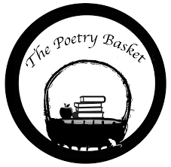  We are now onto learning our third poem. See if your child can recite the two poems that we have already learnt. They are called Chop Chop and Wise Old Owl.  Our Poetry Basket Poem this week is:  Falling Apples  Here is the tree with its leaves so green.  Here are the apples that hang in between.  When the wind blows, the apples will fall.  And this is the basket to catch them all.  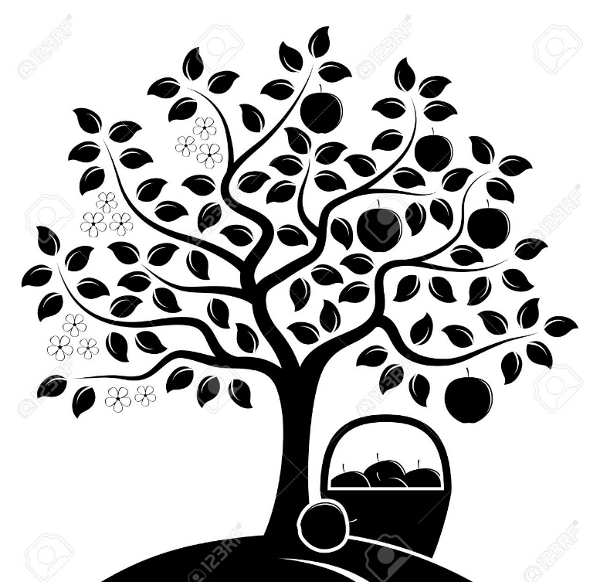 | This week our core text is You Be You .  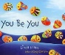  This story supports our learning of the school value Independence and of our school behaviour expectation of Do be Honest.  We will also continue to read familiar stories from our classroom.  We will be singing the Nursery Rhyme “Humpty Dumpty”.  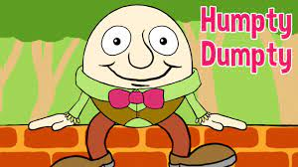
This week our Number Rhyme is ‘5 Little Ducks ‘  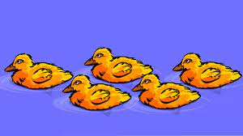  We will continue to subitise groups of objects (0-3). We will practice trying to say how many things we can see without counting.  “What do you see? How do you see it?” We will be encouraging the children to represent their Maths by mark making. | We will be using our creative skills to print fruit for our Autumnal display board.  We will be thinking about colour and what happens when we mix colours and pattern.  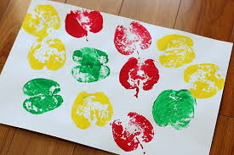  I hope you are enjoying the Nature Nook in the entrance area. Do take the opportunity to talk about the natural world. | We are developing our gross motor skills with our ‘Squiggle while you Wiggle’ dance. We will be practising our mark making whilst we play by writing recipes, making shopping lists or writing telephone messages.  We will also be continuing to make different marks outside using large up/down movements whilst using the water brushes, chalks sand, and in the air with noodles and scarves.  We will be practising the pre writing pattern I and ---- .  We have noticed the leaves falling in our outside area and are developing gross motor skills with the constant sweeping.

