English  This week we are writing a character description based on the story Giraffes Can’t Dance. Focusing on using punctuation correctly. | Maths  We will be looking at comparing numbers, counting objects and working out which has more or less than. We will then be introducing the more and less symbols and ordering numbers. | PE  Our focus in PE in this half term will be multi-skills Please ensure your child has a full, named PE kit including joggers as we will sometimes be outside.
Music  We will be thinking about using our voices to create an effect while singing. | Week beginning 29.09.25  Incredible Me!  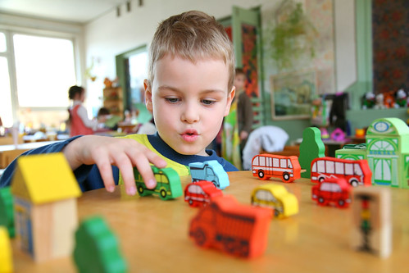 | Science  Animals and Humans  We will be observing, investigating and comparing the human body. We will be working on our questioning skills, identifying what makes a good question.
Poetry  We will be looking at classic Poems from our “Poetry Basket”.  This half term our poems are “All About Me” |  | Art  This half term we are going to be looking at sketching and mark making in Art and using H and B pencils to create different effects.
 | PSHE  This half term we are focusing on looking at our school values and what they mean. This week we are going to be looking at respect. | Geography  Next week we will be looking at maps and how to draw our own. Using the vocabulary: near, far, left, right, behind, next to, opposite.
Phonics
We will be recapping and reviewing Basics 4 and reading CVCC words and B4 tricky words.

