English  We will be completing indepdenent writing each day, towards making a booklet about our country for World Weeks. | Maths  We will be looking at half and quarter of a number and shape. | PE  Our focus in PE in this half term will be multi-skills Please ensure your child has a full, named PE kit including joggers as we will sometimes be outside.
Music  We will be exploring musical sounds and how they can be changed focussing on timbre, dynamics and pitch. | Week beginning 1.6.26  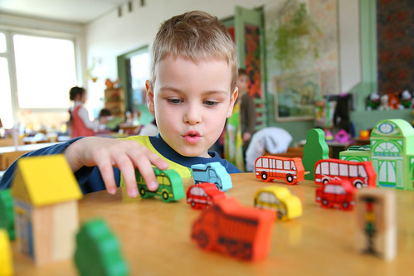 | World Weeks  We will be learning different songs to help us remember about different oceans and continents.
Poetry  We will be looking at classic Poems from our “Poetry Basket”.  This half term our poems are “World” |  | Art  This half term our skill is sewing. We will be practicing threading a needle, and different types of stitches, towards making a final product.
 | PSHE  Our topic this half term is all about diversity and communities. This week we will know that people can enjoy the same and different things. | World Weeks  This week is our first of two weeks of World Weeks. Each class has a different country and they will learn lots of different geographical facts about it.
Phonics
We will be recapping the choose to use sounds and switch it mitch sounds.

