PE  Gymnastics  Mindful minutes   | ENGLISH  Writing Recounts  HANDWRITING  Len’s Ladders including lit, till, little and still, yell and jump and number 16 and sixteen  PHONICS  Daily Phonics Sessions  READING  Daily Story Sessions including Helicopter Stories, Tales Toolkit Stories and Talk for Writing & Learning Poems.  Remember to bring in reading books and diaries every day. Please sign the diary when you have heard your child/ren read. | 15.9.25  Our value this week is:  Collaboration  We will be reading  The Enormous Turnip  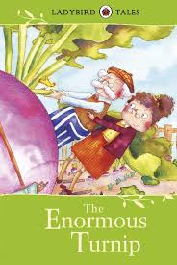 | MATHS  Number  Recognising numbers, comparing numbers and place value.  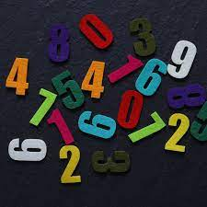 | MUSIC  Songs & rhymes, including Harvest songs  
COMPUTING



XXXX
ART/CRAFT  Mark Making  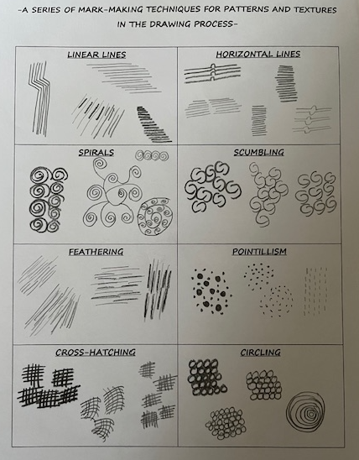  Harvest Man | PSHE  Behaviour Expectations  Values  Reflection  Miss Molly’s School of Manners   | I wonder…  Would you rather…? discussion.   | RE  Places of Worship  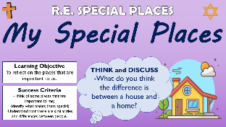 | FINE & GROSS MOTOR  Funky Fingers:  Cutting Skills  Crossing the mid-line  
Homework

Children to neatly decorate their homework books.
Homework went out on 19/9/24 and needs to be returned by 1/10/24.

