PE  Gymnastics  Mindful minutes  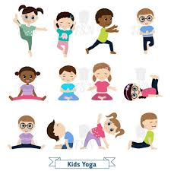 | ENGLISH  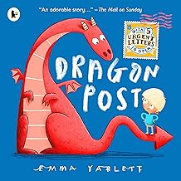  Dragon Post  Writing a letter of apology and using role play to develop ideas.  HANDWRITING  Words based on our story, focusing on flicks getting ready to join.  PHONICS  Daily Phonics Sessions.  READING  Daily Story Sessions & Learn a Poem.  Remember to bring in reading books and diaries every day. Please sign the diary when you have heard your child/ren read. | 19.1.25  We will continue to focus on our school Behaviour Expectations & Values.  We will be reading:  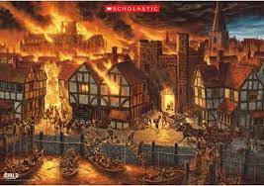  The Great Fire of London Non-Fiction & Stories  Move  Activities based on perseverance. | MATHS  Subtraction using a number line.  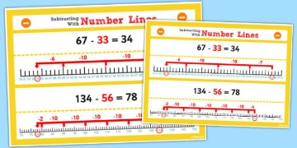 | MUSIC  A focus on singing expressively, playing tuned musical instruments, creative composing, responding to pitch changes and playing, creating and performing rhythmic patterns.  
SCIENCE  We will be looking at Properties of different Materials.  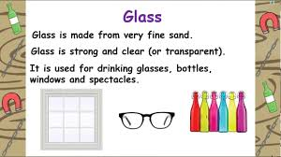 |  |  | HISTORY / ART/ COMPUTING  We will be looking at the Great Fire of London and the chronology of events. Exploration of landscapes, artists and the techniques of using watercolours to create fiery skies. They will be doing web based research too.    RE  We will be looking at role models in ‘Special People’.
PSHE  Behaviour Expectations & Values  Reflection  Circle Time  Me & My Emotions   |  | Homework    Homework was issued on 8/1/25 on The Great Fire of London. Children need to hand in their neat homework on 20/1/25. | FINE & GROSS MOTOR  Funky Fingers  Crossing the mid-line.  Further developing of cutting skills.  

