English  This week we will be planning and writing our own tales tool kit story. | Maths  We will be working on using a number line to complete addition and subtraction. As well as number bonds to 10. | PE  Our focus in PE in this half term will be multi-skills Please ensure your child has a full, named PE kit including joggers as we will sometimes be outside.
Music  We are learning songs for our Christmas Nativity. | Week beginning 17.11.25  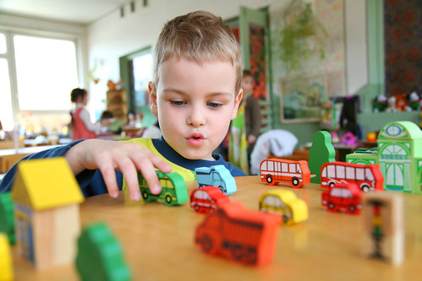 | Science  This week we are going on Autumnal walk looking at identifying signs of seasons.
Poetry  We will be looking at classic Poems from our “Poetry Basket”.  This half term our poems are “Emotions” |  | Art  This half term we are going to be looking at watercolours and the two artists: Van Gogh and Paul Klee.
 | PSHE  This half term we are focusing on looking at our school values and what they mean. This week we are going to be looking at collaboration. | History  This week we are looking at some of the ways in which we find out about the past and identify different ways in which it is represented.
Phonics
We will be working through the choose to use sounds and tricky words.

