WB: 16.10.23
Question of the Week: What parts of the body are important for exploring our sense of taste? All expectations and values

  We will be learning about our sense of taste. We will be exploring why foods taste different and which tastes we like or don’t like. | Our focus value this week is:  Reflection We will be reading:    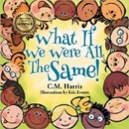    To think deeply or  carefully about something.  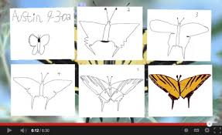  As ‘Reflectors’ we will be learning how to reflect on our work and begin to think about how we can make it even better next time.  We will also be reflecting on the  wonderful work we have done this week. |  | In ‘Squiggle Whilst We Wiggle’ we will be learning these pre-writing patterns:  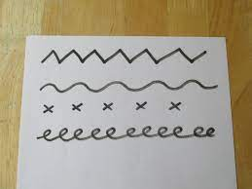   | In maths we will be continuing to develop our skill of ‘Subitising’ – to identfy the number of things in a set simply by quickly looking at them – not by counting them one by one.  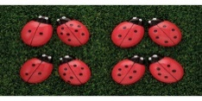
We will be thinking about the different ways we can tell our friends or grown-ups how we are feeling and why we like or dislike something.

  Five Little Pumpkins  F Five little pumpkins sitting on a gate.  The first one said, ‘Oo, it’s getting late.’  The second one said, ‘There are witches in the air.’  The third one said, ‘Well I don’t care.’  The fourth one said, ‘Let's run, run, run.’  The fifth one said, ‘Let's have some fun.’  But oooh went the wind, and out went the light,    And five little pumpkins tumbled out of sight.     | We will be looking at the artwork of  Yayoi Kusama.  The Japanese artist uses a distinct polka dot style of art. The children will then create their own version of Kusama’s polka dot pumpkins.   | Grandma’s Fantastic Words  Proud – ashamed, pleased, proud  Lonely – empty, isolated  Accepted – welcomed  Brave – courageous  Scared – petrified  Happy – cheerful, delighted,  Sad – unhappy, miserable  Anxious – worried, fretful  Angry – cross, annoyed  Calm – peaceful  Sorry – ashamed | Home Learning Tips and Hints  Can you speak in ‘sound talk’ when giving your child instructions? This will help develop your child’s oral blending and segmenting, e.g. ‘Put it in the b-i-n’. ‘Let’s b-r-u-s-h your t-e-e-th’. Ask your child what word you have sounded out.  PLEASE remember to send your child’s reading book and spotty diary to school EVERY day!  Enjoy playing a dice game with your child.

