Question of the Week: Where are some of the world’s most amazing places? What is it like to live in…? WB: 22.6.26

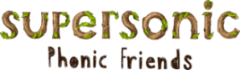  In Phonics we will be continuing to revise our Phonics 4 words and all our tricky and high frequency words. | Handwriting  In handwriting we are focussing on:  - Correct letter formation.  - Letters sitting on the line.  - Tall letters to the top.  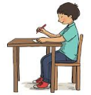  - Capital letters are twice the size. |   Writing    We will be writing a recount of our Church visit and also, a postcard from Iceland sharing some of the fabulous facts we have learned about this country.  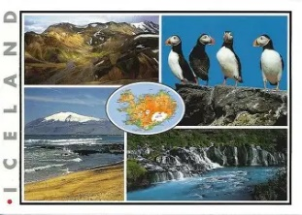 | Maths  In Maths the children will be consolidating their understanding number bonds to 5 and 10 by doing practical games and activities.  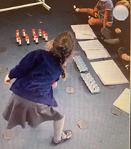
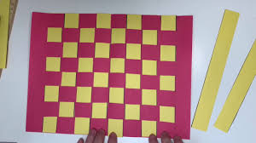  We will be learning how to weave using paper, ribbons and thread. | World Weeks  This week each class will be learning about a cold country in contrast to the country we learned about last week. We will be thinking about the weather, landmarks, food, music and comparing it to the hot country we learned about in our class.  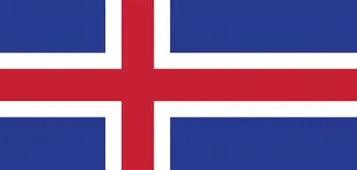 |  |   Friday 26th June 2026  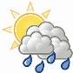  10:15am Start  Coats & Sunhats  Please ensure children have a waterproof coat and a sunhat everyday. Please apply sun lotion before.

