PE  Gymnastics  Mindful minutes  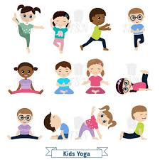 | ENGLISH  Dragon Post – identifying narrative features.  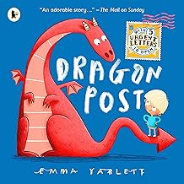  HANDWRITING  Revising letter families and number twenty-five 25  PHONICS  Daily Phonics Sessions.  READING  Daily Story Sessions & Learn a Poem.  Remember to bring in reading books and diaries every day. Please sign the diary when you have heard your child/ren read.  SPELLINGS  Please continue to read and learn the High Frequency, Tricky and Common Exception words. | 12.1.26  We will continue to focus on our school Behaviour Expectations & Values.  We will be reading:  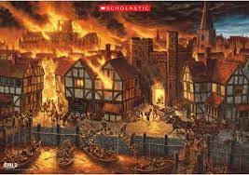  The Great Fire of London Non-Fiction & Stories  ACTIVITIES FOR HOME  Write a diary entry as if you were Samuel Pepys.  Create a Great Fire of London mini book with Key Facts.  Draw an Elizabethan House.  Research GFoL on BBC Bitesize. | MATHS  Fact Families  & Bar Model  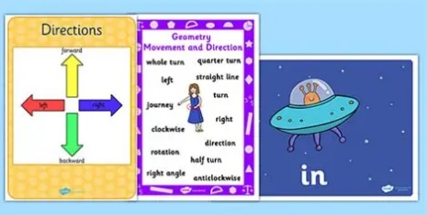  Position and Direction | MUSIC  A focus on singing expressively, playing tuned musical instruments, creative composing, responding to pitch changes and playing, creating and performing rhythmic patterns.  
HISTORY / ART
We will be looking at the Great Fire of London and focusing on Samuel Pepys too. The children will be drawing pencil portraits of Samuel Pepys using a variety of sketching pencils and mark making techniques.


RE
We will be focusing on people special to them beginning with our own families.
PSHE  Behaviour Expectations & Values  Reflection  Circle Time  Me & My Emotions   |  | Homework    New homework will be issued on 8/1/26 on The Great Fire of London. Children need to hand in their neat homework on 20/1/26. | FINE & GROSS MOTOR  Funky Fingers  Crossing the mid-line.  Further developing of cutting skills.  

