Summer 1 Week 2
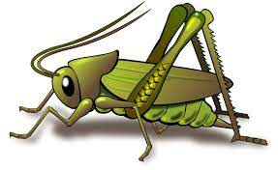
Question of the Week: What do you know about the earth and space? What is it like on the Moon?
Activities based on the interests of the children….
This week’s story is Dinosaur Rocket by Penny Dale  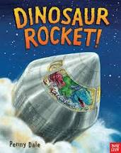  We will be developing our communication and language skills with special words throughout the week. We have been learning key vocabulary from the book and thinking about alternative words for that vocabulary.  Conversation starter – how would you feel about travelling to space? | Poetry basket    Our Poetry Basket Poem this week is;  I Have a Little Frog  I have a little frog,  His name is Tiny Tim,  I put him in the bathtub,  To see if he could swim.  He drank up all the water,  And gobbled all the soap.  And when he tried to talk,  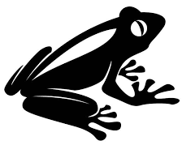  There were bubbles in his throat. | Conversation starter  ‘What would it be like on the Moon?  We will be talking about the Earth and Space, singing Space songs and rhymes, constructing and drawing rockets and creating space pictures. We will be thinking about 2D and 3D shapes. We will be Moon walking and talking about gravity.  We will be singing the Nursery Rhyme ‘Twinkle Twinkle little star’  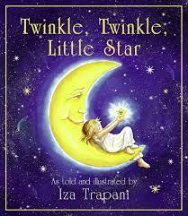
Maths  We will be subitising up to 5, looking at different combination of objects.  “What can you see? How can you see it?”  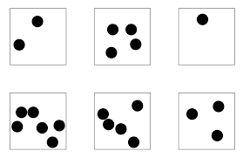  We will also be exploring how we can represent numbers, such as using our fingers, drawnig 5 things, clapping 5 times. | Expressive arts and design  The children will role - play being astronauts and construct/build rockets. They will be encouraged to plan, build and describe their constructions.  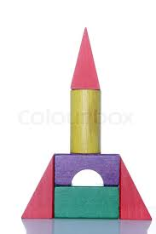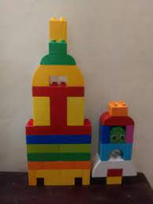  They will also be making rockets from recycled materials. | Phonics  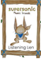  This week we will be continuing to develop our ‘Phonological Awareness’ by listening to “robot talk” for a word and then identifying the correct word. E.g. I say C - -a – t. Can you point to that picture?  Ideas for phonic activities at home:  When you are asking your child to do something, break down one of the words. E.g. Can you pull up your z – i - p?  Can you get your c – oa –t ?  Please can you clean your t – ee - th?

