English  We will looking at instructions and writing our own, using adverbs and bossy words. | Maths  We will be looking at equal and unequal groups and learning about arrays. | PE  Our focus in PE in this half term will be multi-skills Please ensure your child has a full, named PE kit including joggers as we will sometimes be outside.
Music  We will be exploring musical sounds and how they can be changed focussing on timbre, dynamics and pitch. | .  Week beginning 4.5.26  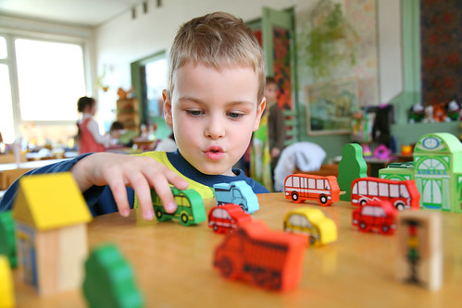 | Science  This week we will be looking at plants and trees.
Poetry  We will be looking at classic Poems from our “Poetry Basket”.  This half term our poems are “Animals” |  | Art  We will be looking at the artists; Damien Hirst and completing different printing activities.
 | PSHE  This half term we are focusing on Me and My Family. | History  We will be looking at Victorian holidays. Using our knowledge of land and air travel.
Phonics  We will be working through the Switch it Mitch sounds and tricky words. | PSHE  This half term we are focusing on Me and My Family.

