PE  Multi-Skills    Playground Equipment Games  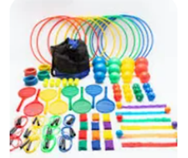  Focus: Idependent play | ENGLISH  Luna Loves to Dance  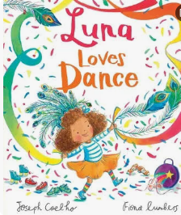  This week we will publishing and sharing our own stories inspired by Luna loves to Dance  HANDWRITING  Practising the letter formation families and 16 sixteen.  PHONICS  Daily Choose to Use Phonics Sessions  READING  Daily Story Sessions & Learn a Poem.  Remember to bring in reading books and diaries every day. Please sign the diary when you have heard your child/ren read. | 19.10.26  Our question of the week is:  What can we learn by thinking about our mistakes?  Our value this week is:  Growth Mindset  Our Behaviour Focus this week is:  All Behaviour Expectations  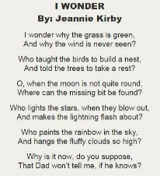  Poem we are Learning: | MATHS  Number  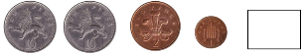  This week we will be learning about money. Activities will include, knowing the value of coins, finding the total amount of a group of coins and selecting the correct coins to make the total amount shown. We will also be using place value and number facts to solve money problems.  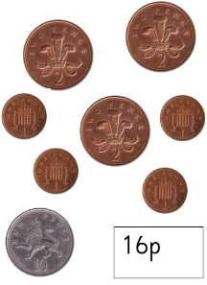 | MUSIC    To internalise the pulse.  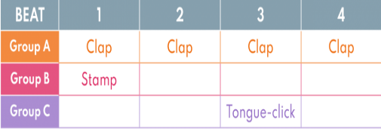  To compose simple beat patterns and follow a graphic score.
COMPUTING
To create a program that uses a “timer-after” command and explain what it does in my program.

To predict what will happen in a program that includes a “timer-after” command.
ART  Sketching and Mark Making  We will be continuing to explore different effects using new mark making techniques.  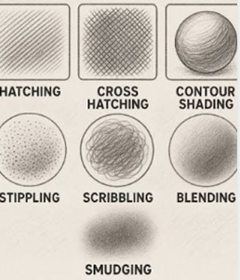 | PSHE  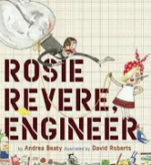  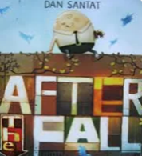  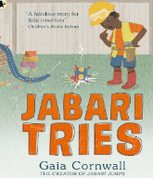  What is Growth Mindset and how does it help us?   | Science  This week we will be talking about the importance of a healthy mind and reinforcing the link to exercise.  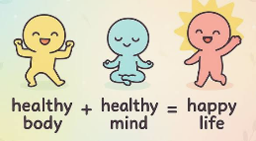 |   Growth Mindset    Can your children complete a ‘Growth Mindset’ challenge and as a family, talk about the importance of ‘yet’. |   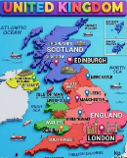  Geography  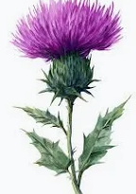  We will be learning about the four countries that make up the U.K.  This week we will be learning about Scotland including capital city, national flower, highest mountain and longest river.

