WB: 26.1.26 | Value: Independence | Behaviour Expectation: Do look after property
Question of the Week: What makes Earth Special?

We will be reading the story:  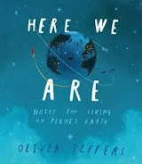 |   Grandma Fantastic Words  hard, tricky,  complicated | Poetry Basket Poem  Climb aboard the spaceship, We’re going to the moon.  Hurry and get ready, we’re going to blast off soon.  Put on your helmet, and buckle up real tight. Here comes the countdown, let’s count with all our might – 10.9.8.7.6.5.4.3.2.1. BLAST OFF! | Tales Toolkit  We will be continuing to create class Tales Toolkit using symbols. We will be substituting But for Unfortunately and So for Fortunately Can you make up a story at home? Remember to use the sentence starters
   | One upon a time/ A long time ago there was a ……. who lived in …………  One day……  Unfortunately …..  Fortunately …..  Snip snap snover, the story is over. Snip snap snout the story is out/ Tap the nail the nail bends, this is how the story ends.
  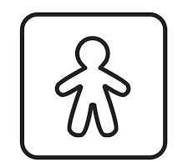
  
  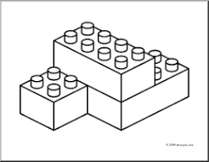
  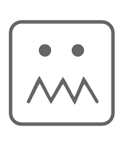
  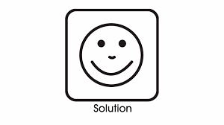
Curious Conversations:
Would you rather live in space or underground? Imagine how that feels. (Just Imagine)

Phonics  We will be learning to write the spellings for the sounds:  oo oo ar or  We will be learning to write the High Frequency Word see and Tricky words: are, all. Please see Home Learning for further details | We are starting to explore and name the properties of SOLID (3D shapes).  