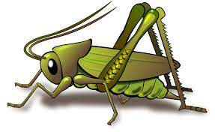
Value of the Week: Good Manners Autumn 2 Week 5
Activities based on the interests of the children….
This week we will be thinking again about Good Manners – We will be reminding ourselves what it means to treat others with courtesy and politeness and behave well towards them.    Our behaviour expectation for this week is Do be polite and do be gentle.  We will also be continuing to learn about how to look after our classroom and each other, to work hard and to be kind and helpful. | We will be listening to stories, rhymes and fairy tales.    Our Poetry Basket Poem this week is:  I Can Build a Snowman  I can build a snowman,  I can build it high,  I can build a snowman,  Up into the sky. | This week our core text is Goldilocks and the Three Bears.  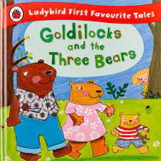  We will be developing our love of reading familiar stories from our classroom, retelling stories and reciting poems.  We will be singing the Nursery Rhyme ‘Old Sing a Song of Sixpence’  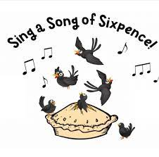
This week our Number Rhyme is  5 Little Monkeys  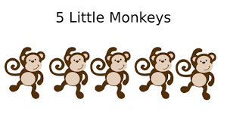  We will continue to subitise groups of objects (0-3). We will be noticing groups of objects and know that a group of 3 can be seen as 2 and 1 or 1,1 and 1 yet they remain a group of 3.  We will be sorting bears and using our vocabulary of size. | We will be using different media and materials to create models and pictures.  We will also be making story telling puppets using joining skills.  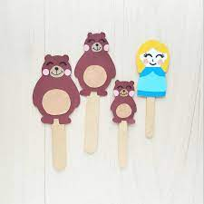 | Listening Len is our supersonic phonic friend. With his help we are learning to be good listeners. In the classroom we have a puppet and we have learnt some new games which your children may tell you about.  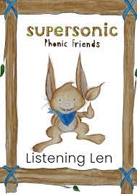  This week we be exploring Body Percussion. We will be distinguishing between sounds and remember a pattern of sound  Ideas for phonic activities at home:  This is a game to play with your family, the more the merrier. One person starts with making a body percussion sound (tap, clap, stamp, click etc) and passing it on the person next to you in the circle. Copy and pass the sound on. Extend with making a pattern to copy.

