WB: 12.1.26 | Value: Perseverance | Behaviour Expectation: Do work hard
Questions of the Week: Were all dinosaurs the same?

We will be reading the story:  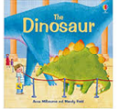 | Grandma’s Fantastic    happily luckily fortunately  unhappily unluckily unfortunately | Poetry Basket Poem  I’m a T Rex, I’m big and mean  I’m the biggest and the baddest on the scene  With my razor sharp teeth all shiny and clean  I’m a T rex, I’m big and mean. When people see me coming they run and scream, cause I’m a T rex I’m big and mean.  Raaaaaaaaaaah! | Tales Toolkit  We will be continuing to create class Tales Toolkit using symbols. We will be substituting But for Unfortunately and So for Fortunately Can you make up a story at home? Remember to use the sentence starters
   | One upon a time/ A long time ago there was a ……. who lived in …………  One day……  Unfortunately …..  Fortunately …..  Snip snap snover, the story is over. Snip snap snout the story is out/ Tap the nail the nail bends, this is how the story ends.
  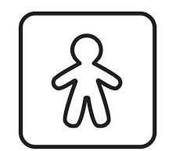
  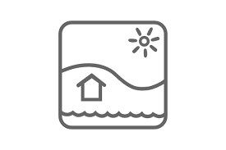
  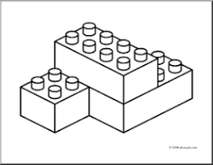
  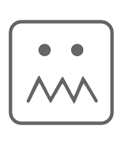
  
Curious Conversations:
Would it be a good thing or a bad thing if dinosaurs roamed the land?
Would you rather be a TRex or a mouse? Why?
Phonics  We will be learning to write the spellings for the sounds:  y z zz qu  .  We will be learning to write the tricky words he, she, we, be and me, and the high frequency word will. Please see Home Learning for further details. | Our value this week is -  Perseverance    To keep on putting in effort to achieve something, even if is challenging  The children will demonstrate in a variety of ways different levels of perseverance throughout their learning this week including .  Our behaviour expectation this week is: Do work hard

To answer the questions of the week How Do We Know Dinosaurs Existed? and Were all dinosaurs the same? We will be become ‘palaeontologists’ and explore ‘dinosaur bones.’ We will be making fossils out of salt dough.  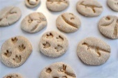 | We will be revisiting different ways to join:  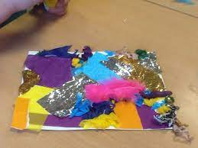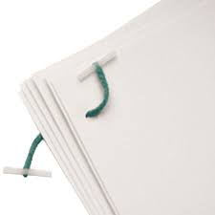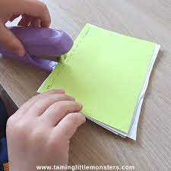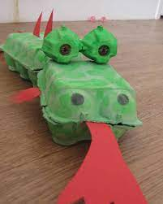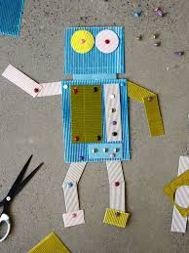 | We will be introducing a new joining technique called a ‘flange.’ We will be making cylinders out of paper, snipping the end and then deciding the best way to secure it – selloptape, masking tape or glue. (sellotape and masking tape make it more secure, sellotape is transparent and you can use a felt tip pen to colour on masking tape to match the model.  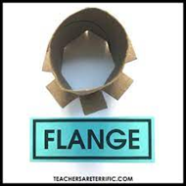
  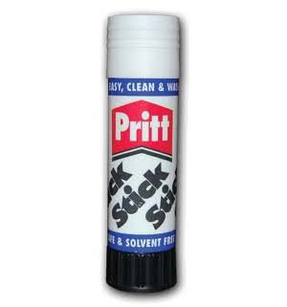 | 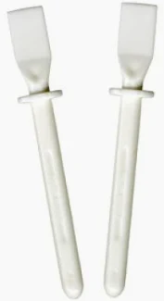 | 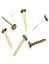 | 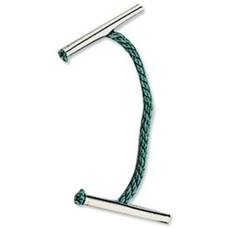 | 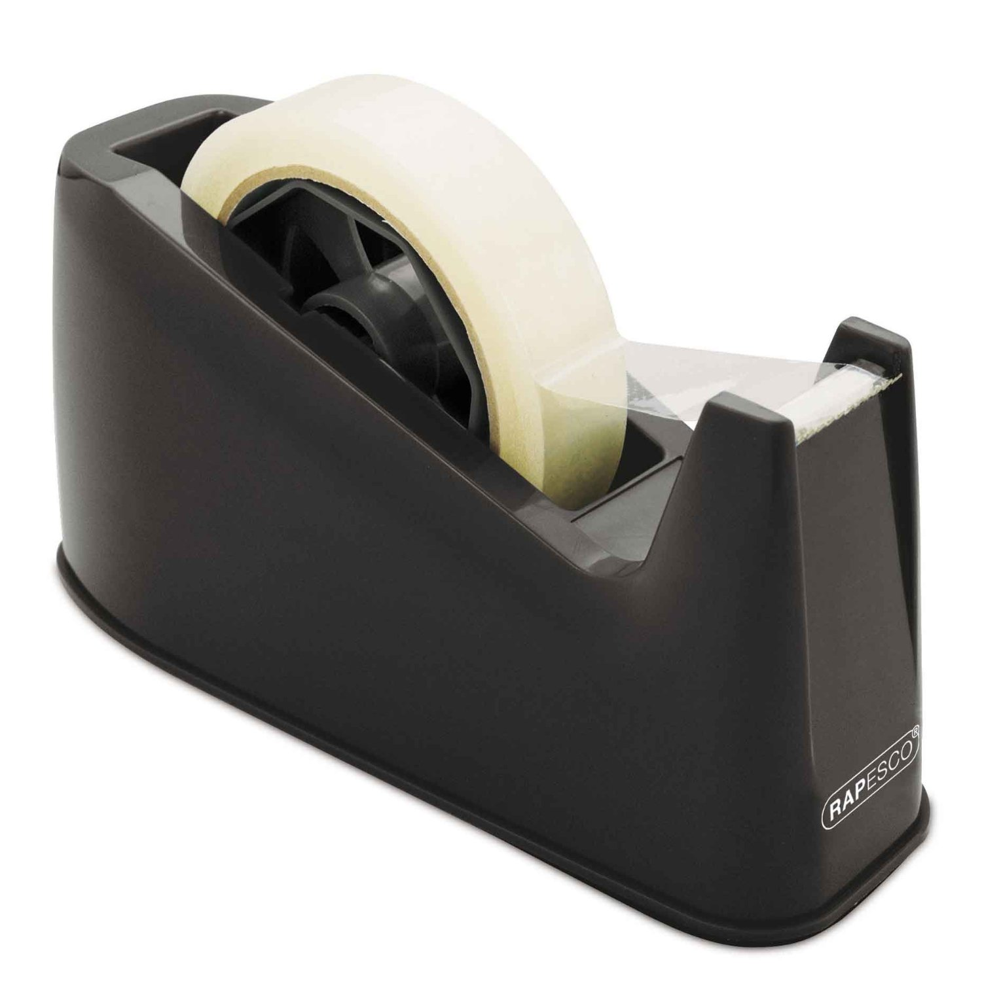 | 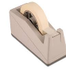 | 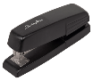
  Glue stick | PVA glue | Split pins | Treasury tags | cellotape | masking tape | stapler
I Am a Palaeontologist  https://www.youtube.com/watch?v=B7zo2zY1Zqg | Maths  We will be ordering the length of dinosaur footprints. We will be asking the questions: How do we know this is the longest? How do we know this is the shortest?  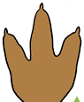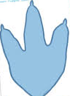 | Please share Library Book Club  

