PE  Gymnastics  Mindful minutes  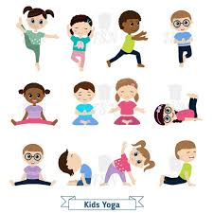 | ENGLISH  Plan and rehearse a letter to an ‘Animal Welfare Expert’  HANDWRITING  Continuing our focus on flicks, getting ready to join. Words related to our English text.  PHONICS  Daily Phonics Sessions.  READING  Daily Story Sessions & Learn a Poem.  Remember to bring in reading books and diaries every day. Please sign the diary when you have heard your child/ren read.  . | 26.1.26  We will continue to focus on our school Behaviour Expectations & Values.  We will be reading:  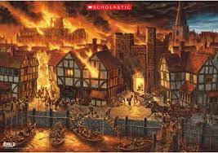  The Great Fire of London Non-Fiction & Stories | MATHS  Subtraction using partitioning method.  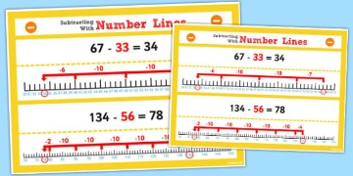 | MUSIC  A focus on singing expressively, playing tuned musical instruments, creative composing, responding to pitch changes and playing, creating and performing rhythmic patterns.  
SCIENCE  We will be looking at Materials and objects and which materials they are made from and why.  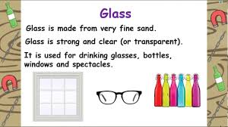 |  |  | HISTORY / ART/ COMPUTING  Programming Blue Bots  Ordering of the Events of The Great Fire of London  The children will be creating fiery skies landscape art, based on focus artists.    RE  We will be looking at ‘Special People’ such as Jesus.  GEOGRAPHY  Map of London 1666  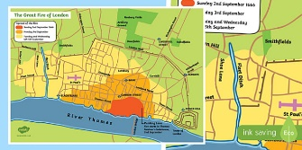
PSHE  Behaviour Expectations & Values  Reflection  Circle Time   |  | Homework    New homework was issued on 22/1/26 on Science: Materials and is due in on 3.2.26 | FINE & GROSS MOTOR  Funky Fingers  Crossing the mid-line.  Further developing of cutting skills.  

